**PROJECT TITLE**

**BRIEF SUMMARY OF PROJECT:**

**Objectives: Deploying NextCloud inside VM running on Azure**

**Outcomes: Website hosted in the NextCloud accessible to all**

**Where it can be used: Anywhere where hosting website is important with full-control over the web content and the resource and costing is not an issue.**

**Key Steps to perform**

1. Set up a VNet, subnet, and NSG.
2. Create and configure the VM.
3. Use Bastion for secure SSH access.
4. Install and configure Nextcloud.
5. Enable and configure monitoring and alerts with Azure Monitor, Application Insights, and cost management features.

Setting up and configuring an Azure Virtual Machine for deploying a Nextcloud server, including key Azure monitoring features for managing and maintaining VM performance and availability.

**Network Architecture**

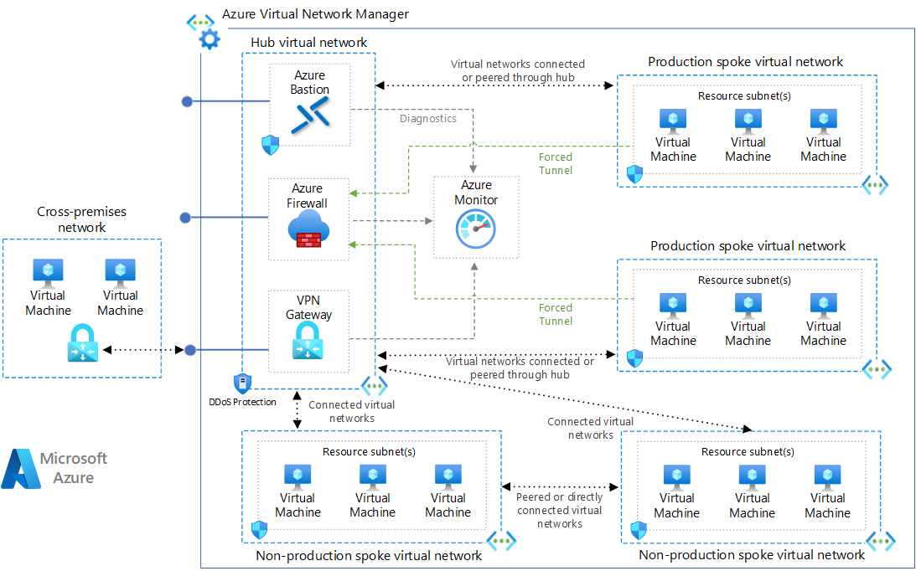

**Steps to Set Up the Azure VM and Deploy Nextcloud**

1. **Create a Virtual Network (VNet)**
   * Log into your Azure portal, navigate to "Virtual Networks," and create a new VNet.
   * 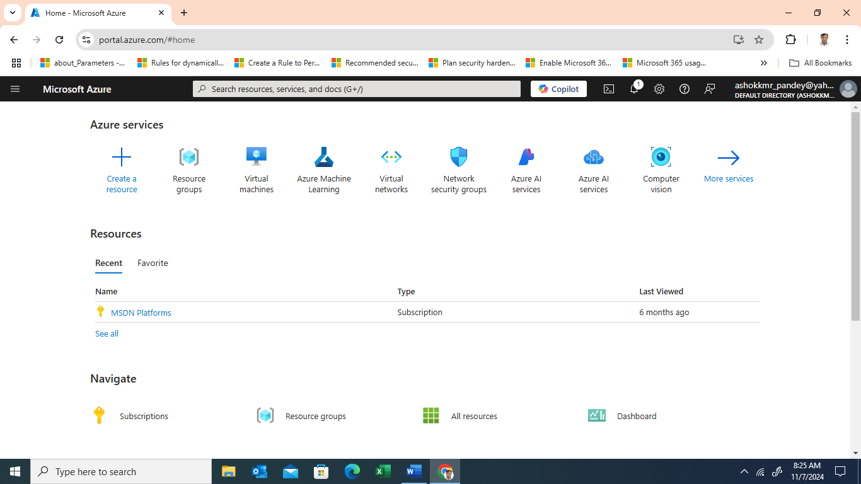

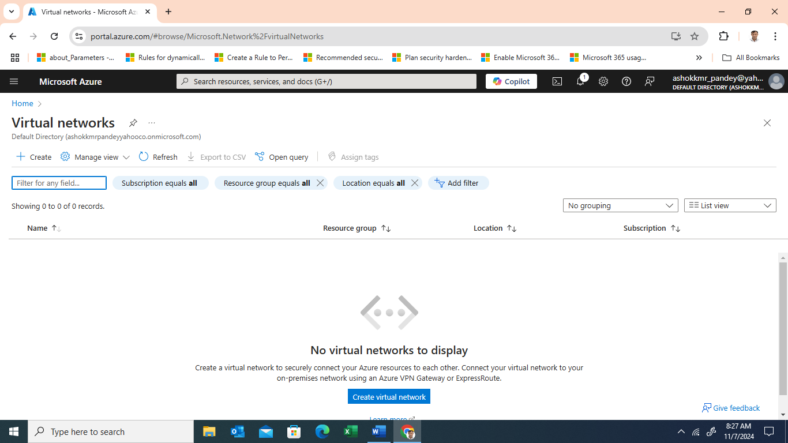

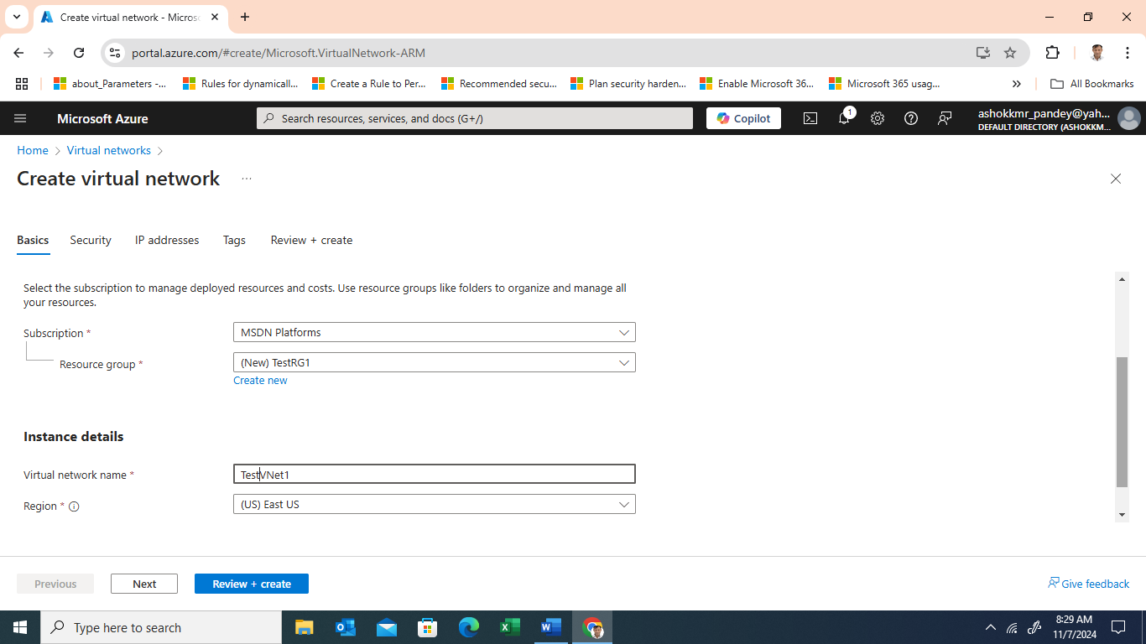

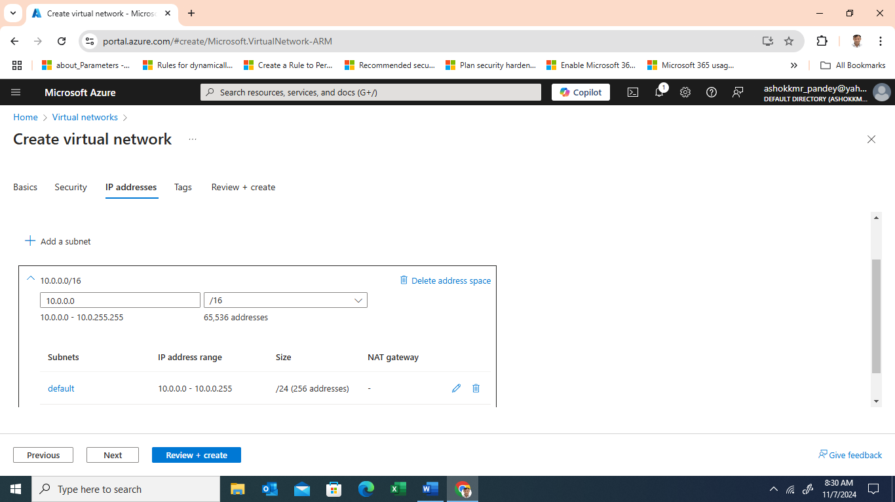

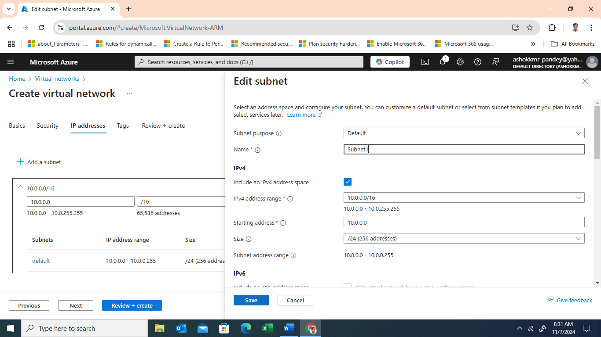

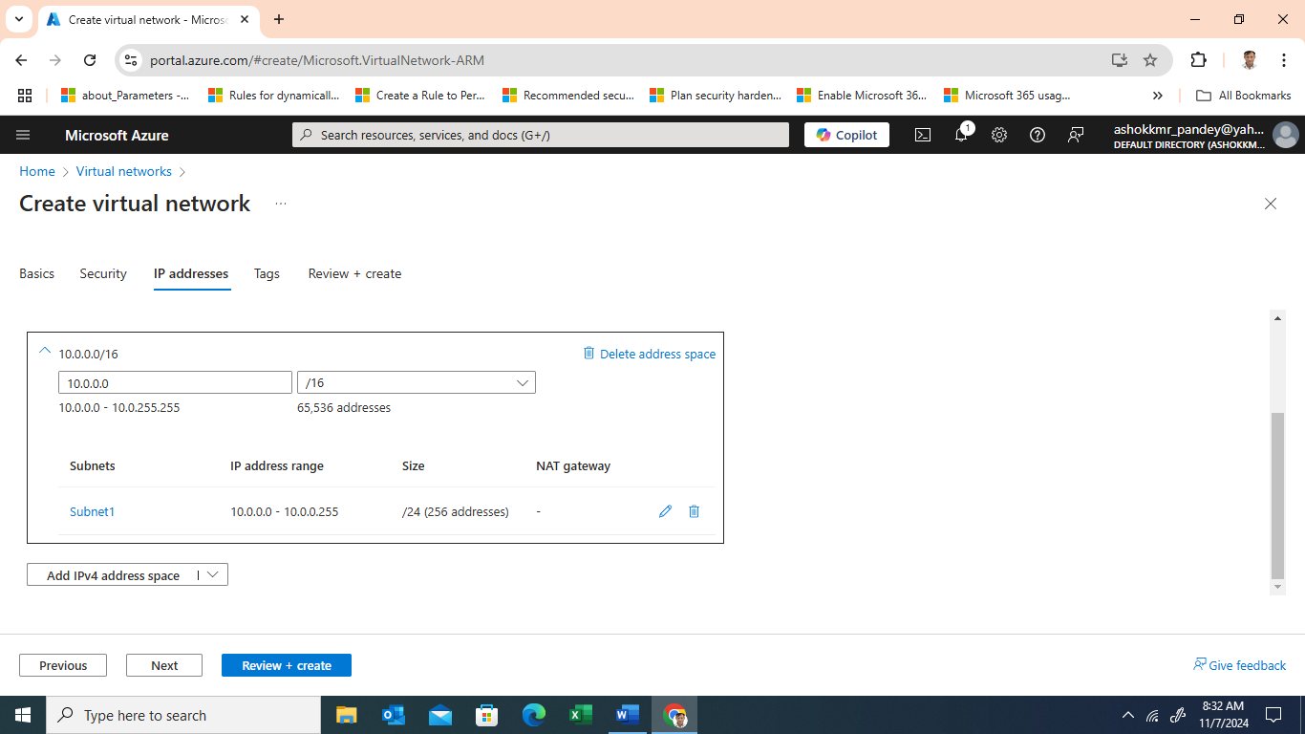

* + Define a name, address space (e.g., 10.0.0.0/16), and create at least one subnet (e.g., 10.0.0.0/24).
  + This network will allow your VM to communicate securely within the cloud environment.

1. **Create the Network Security Group (NSG)**

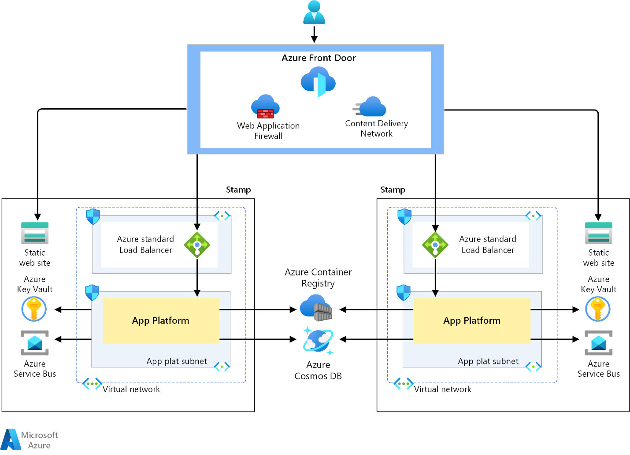

* + In the Azure portal, create an NSG to control inbound and outbound traffic.

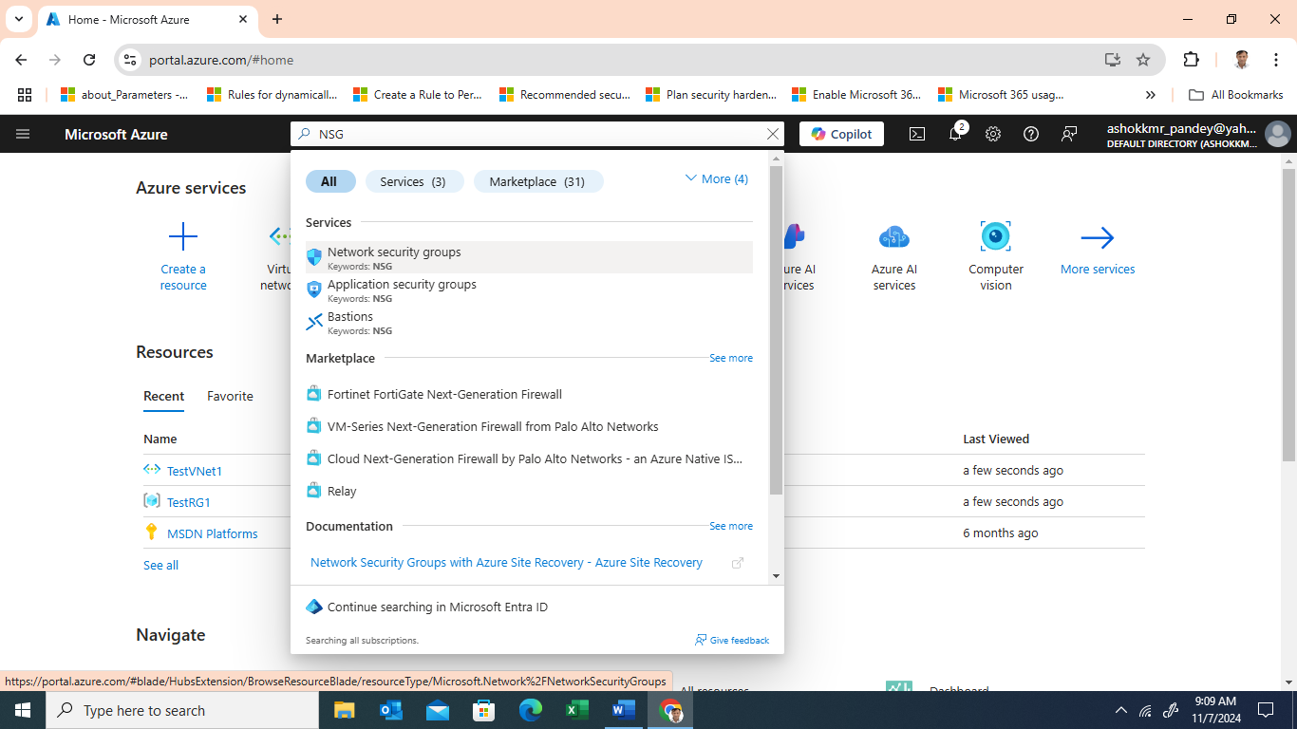

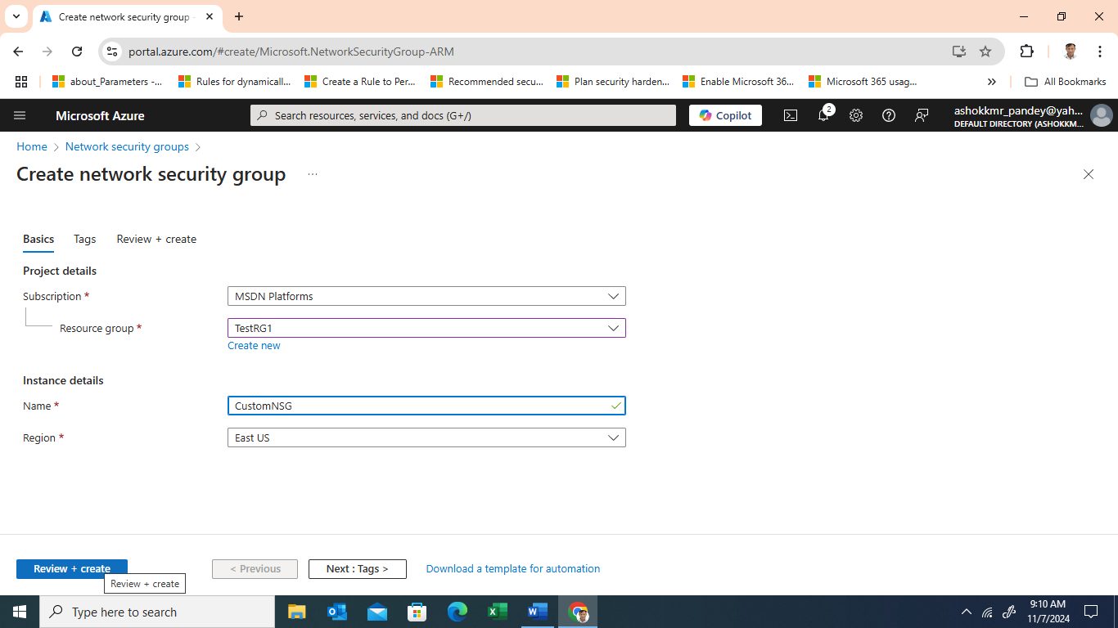

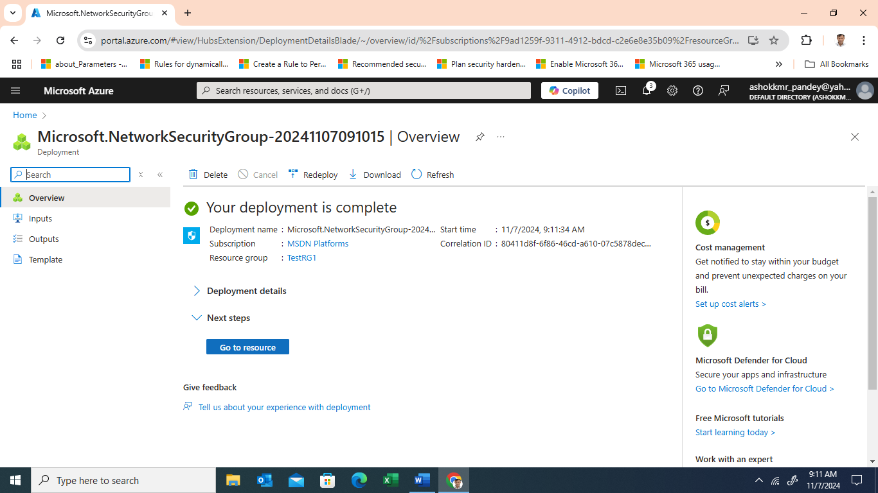

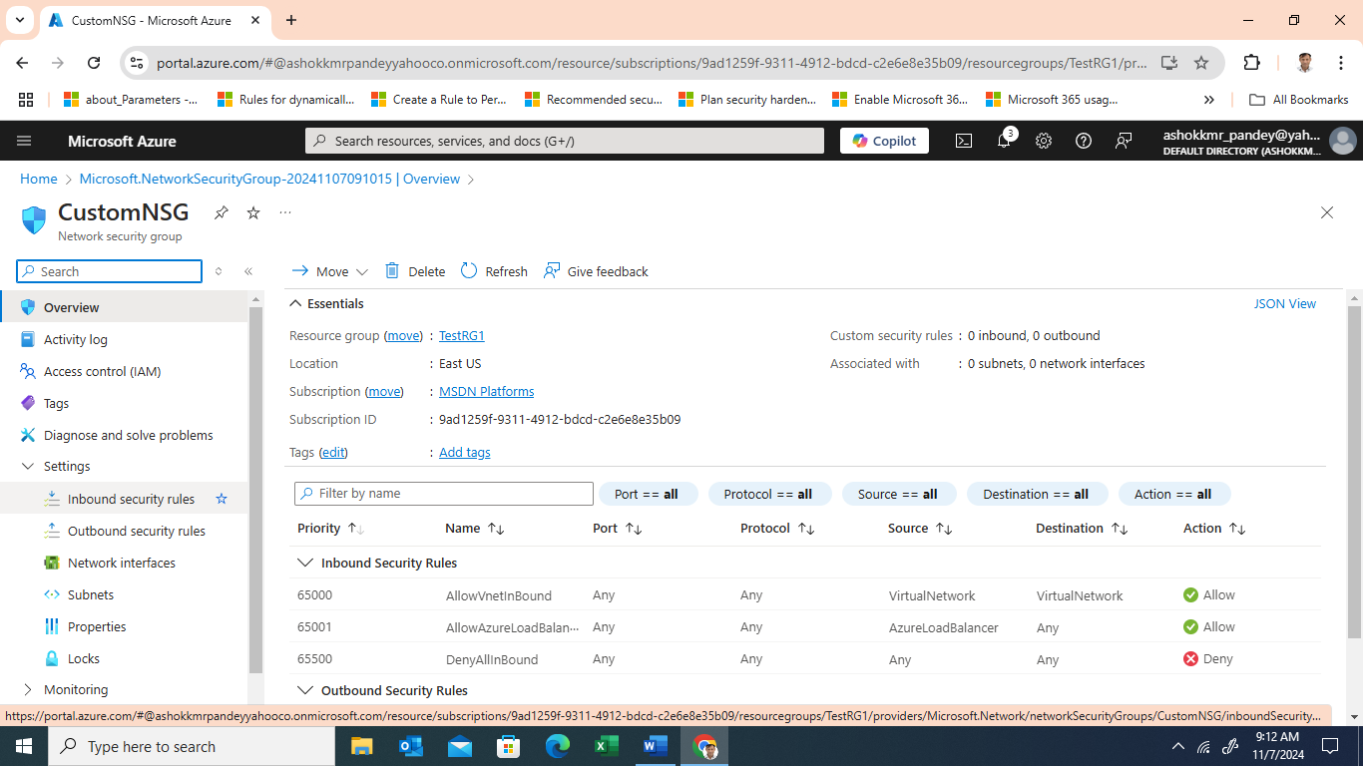

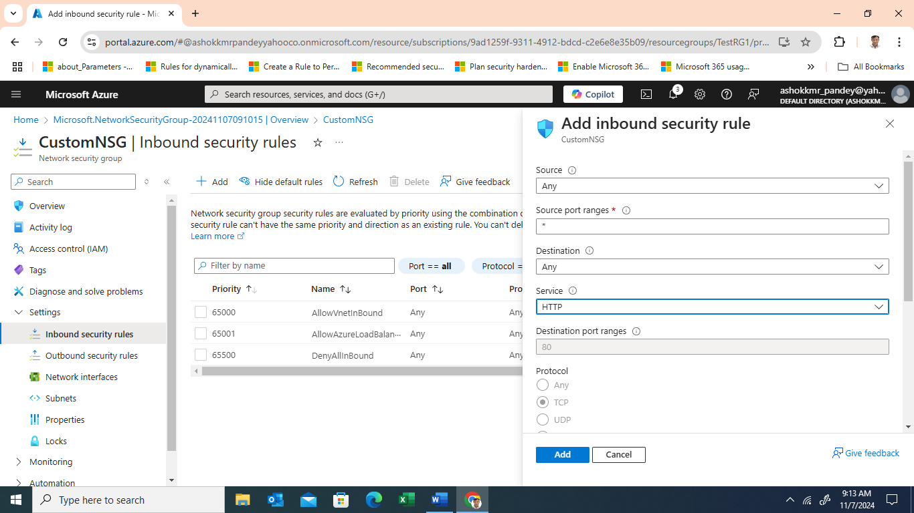

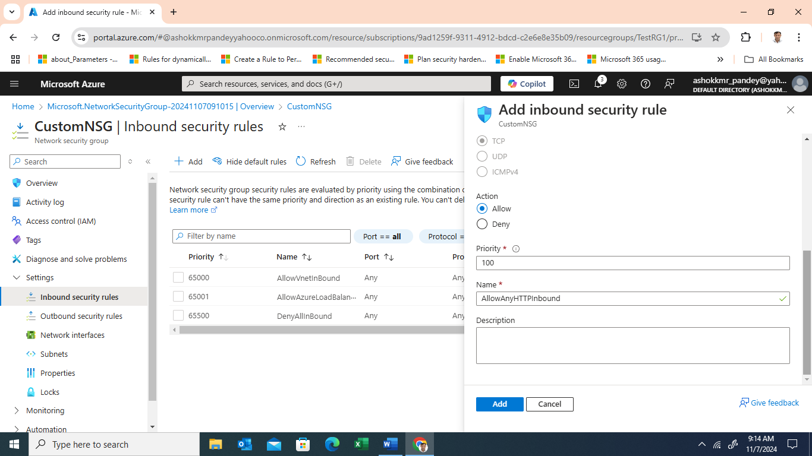

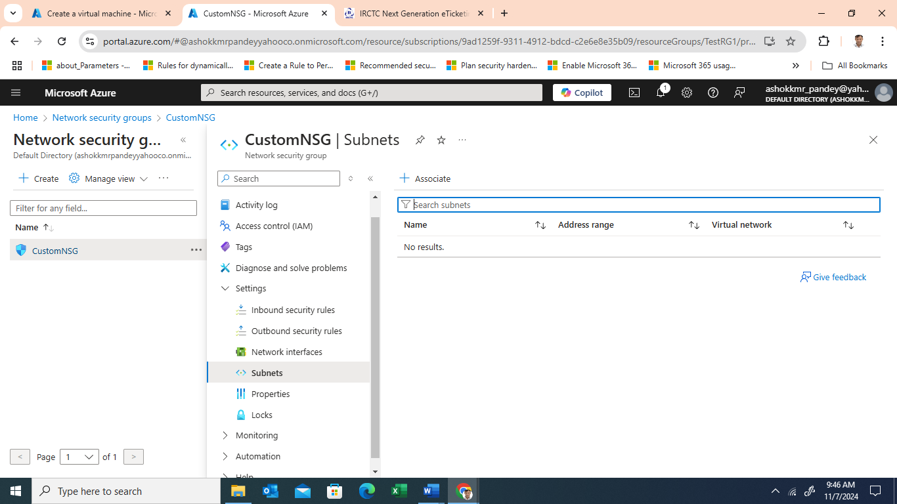

Note: -Repeat the same step to add rules for both Https and SSH

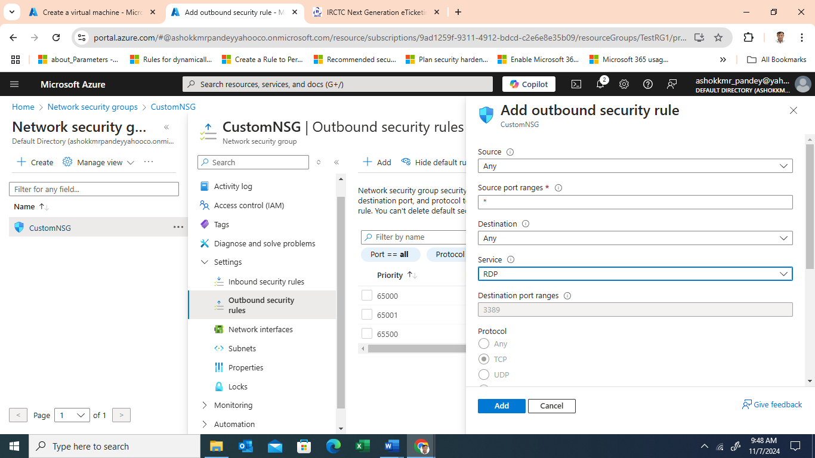

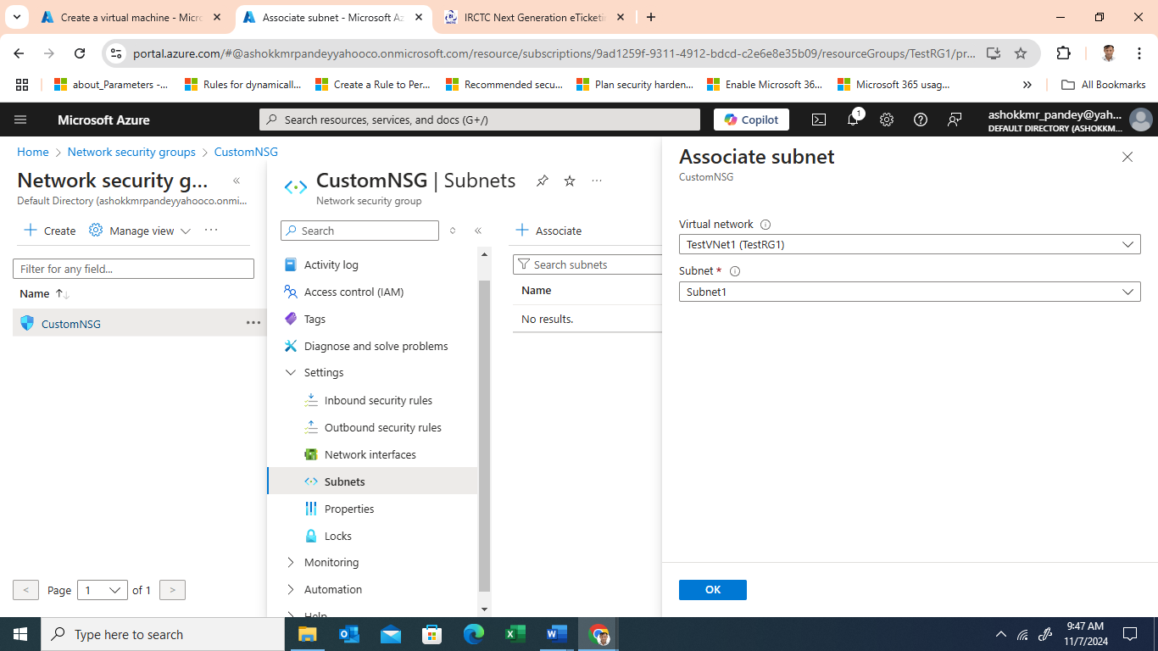

* + Add rules to allow SSH on port 22 (initially), HTTP on port 80, and HTTPS on port 443.
  + Later, you’ll use Azure Bastion for SSH access, eliminating the need to open SSH to the public.

1. **Create the Virtual Machine (VM)**

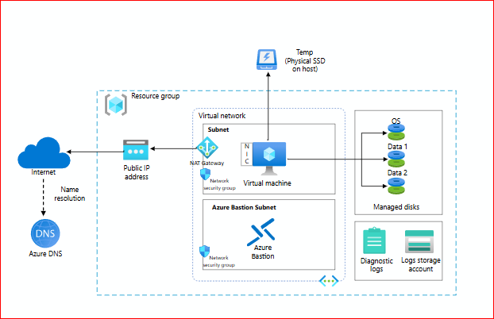

* + From the "Virtual Machines" section, create a new VM, selecting the appropriate operating system (e.g., Ubuntu).
  + 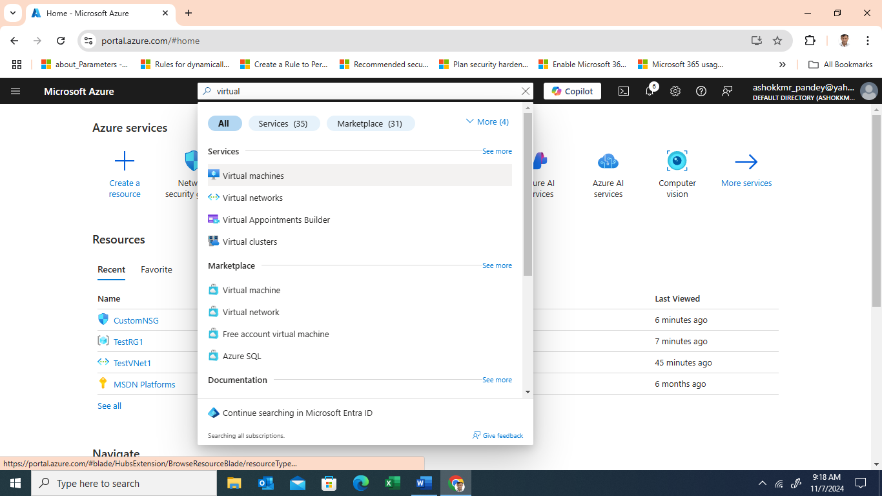

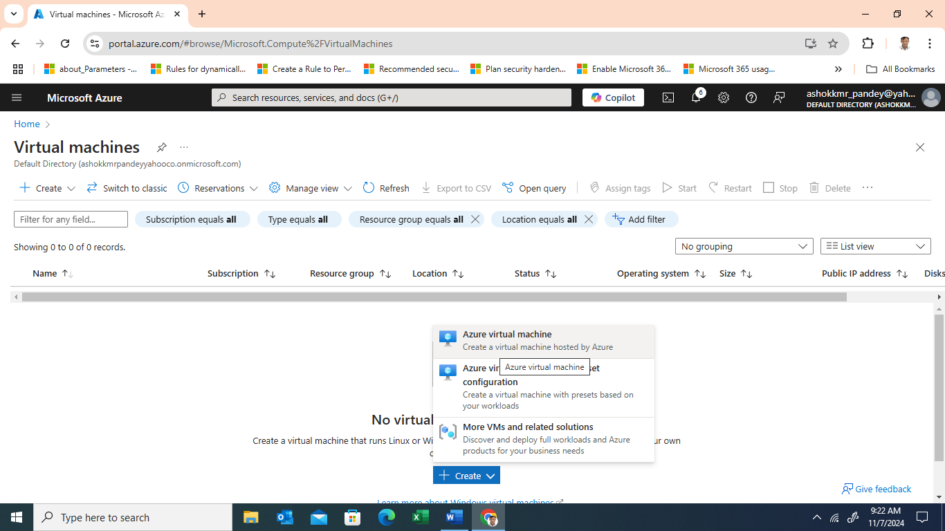

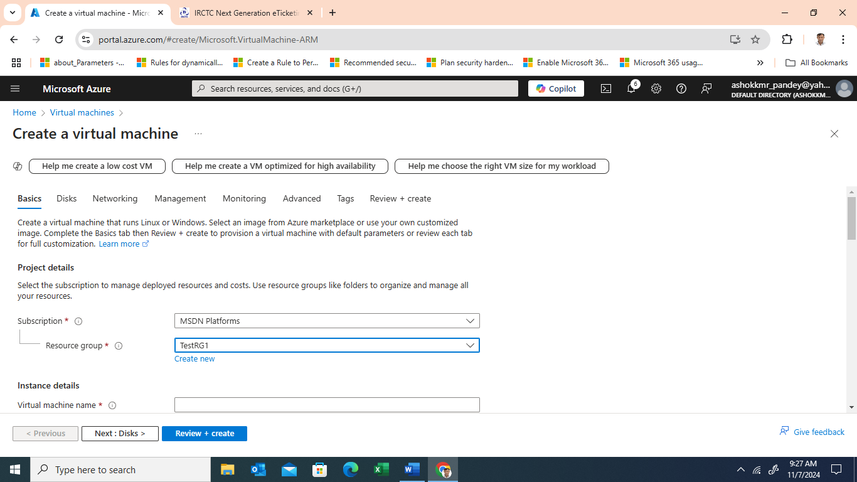

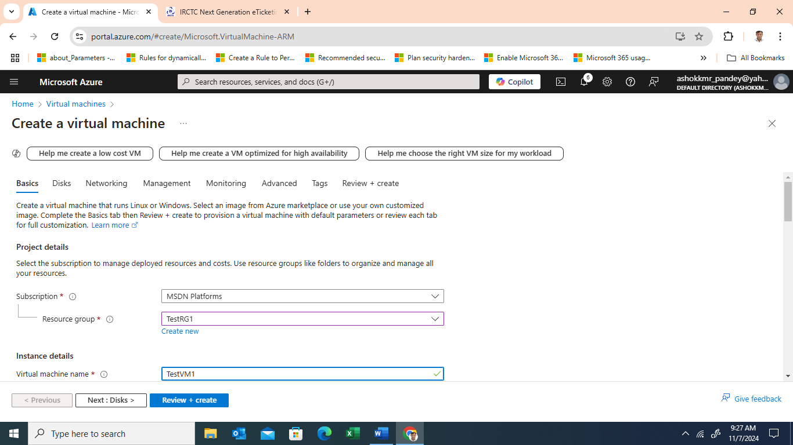

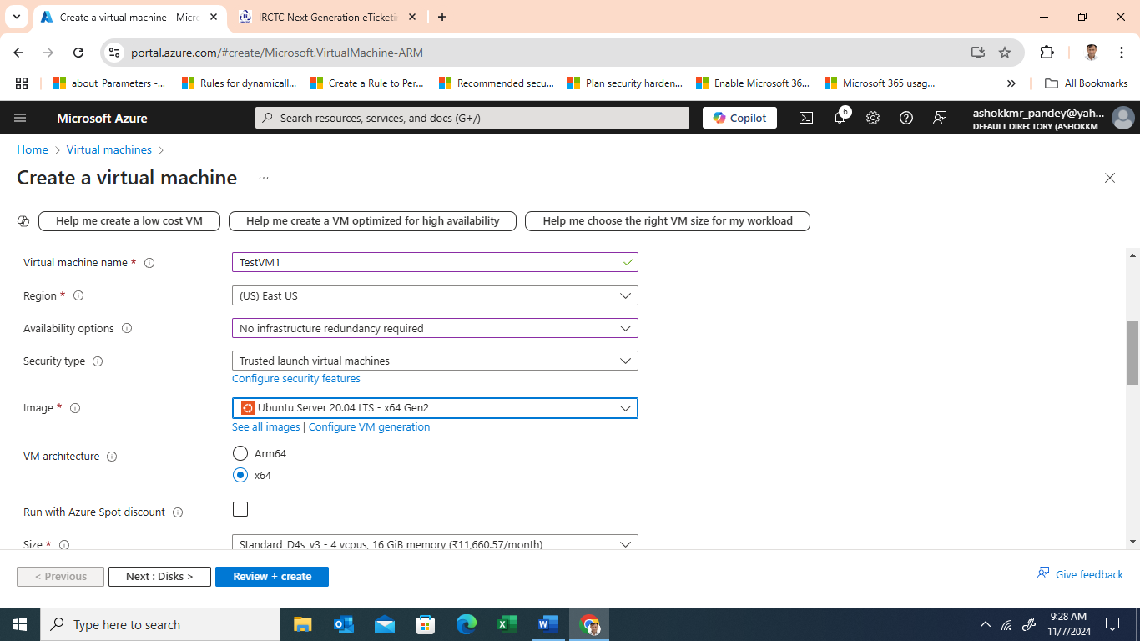

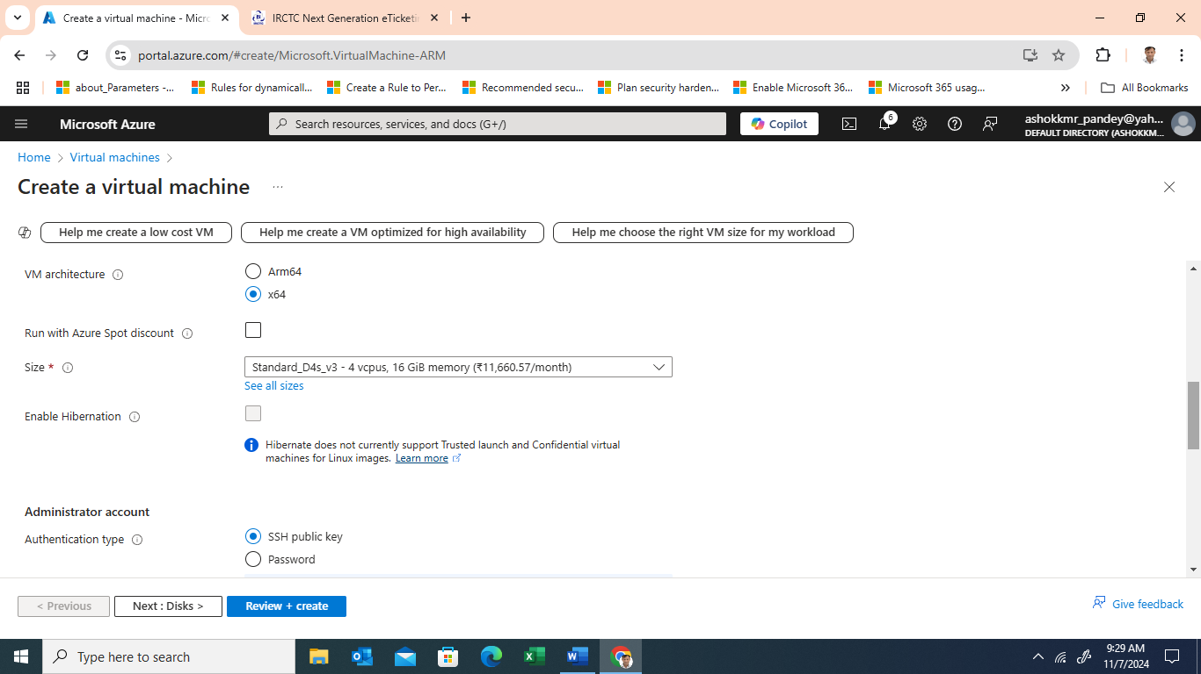

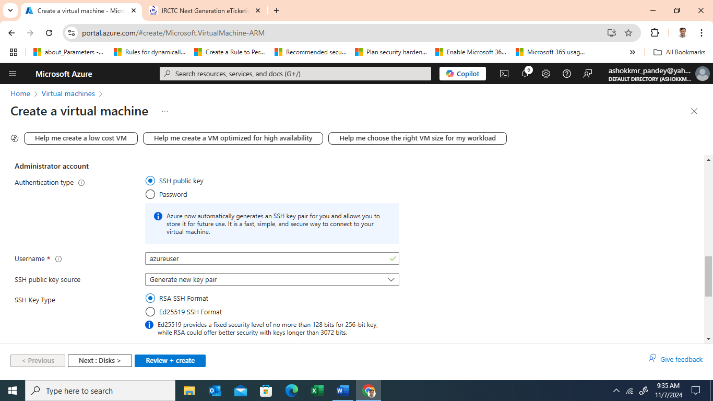

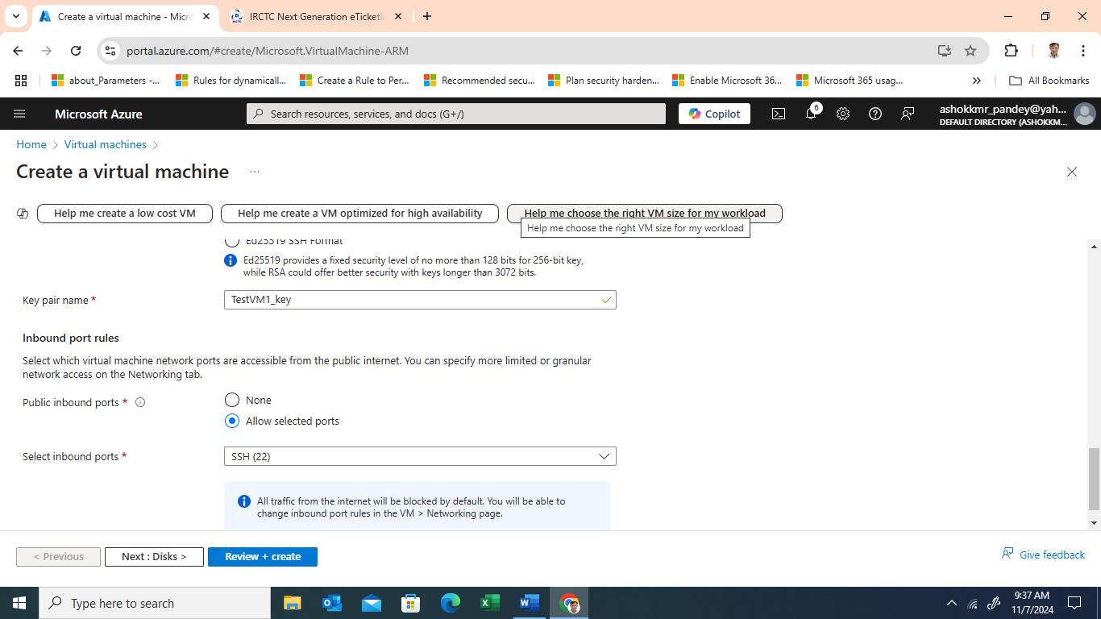

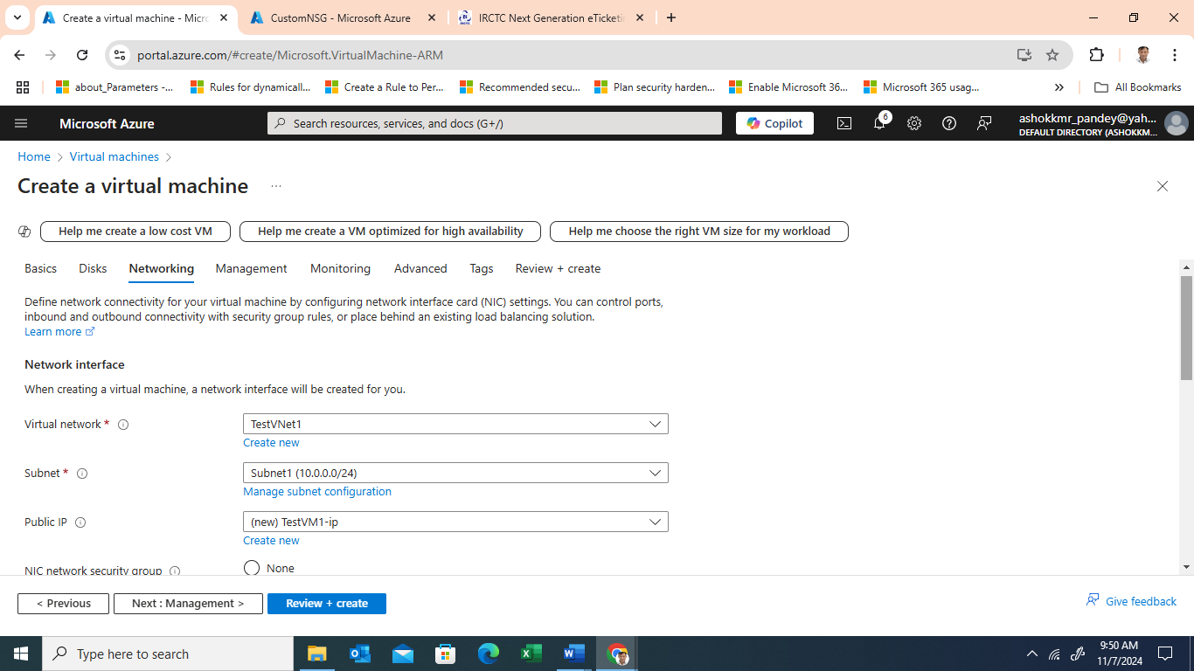

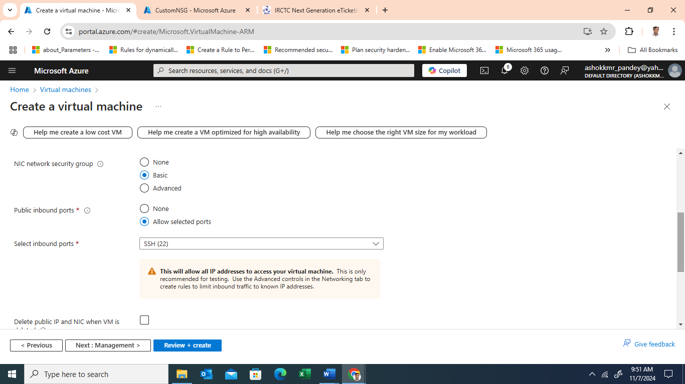

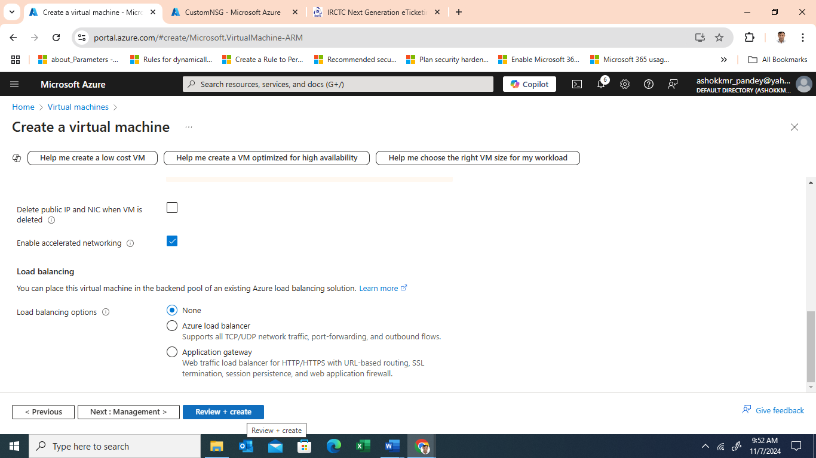

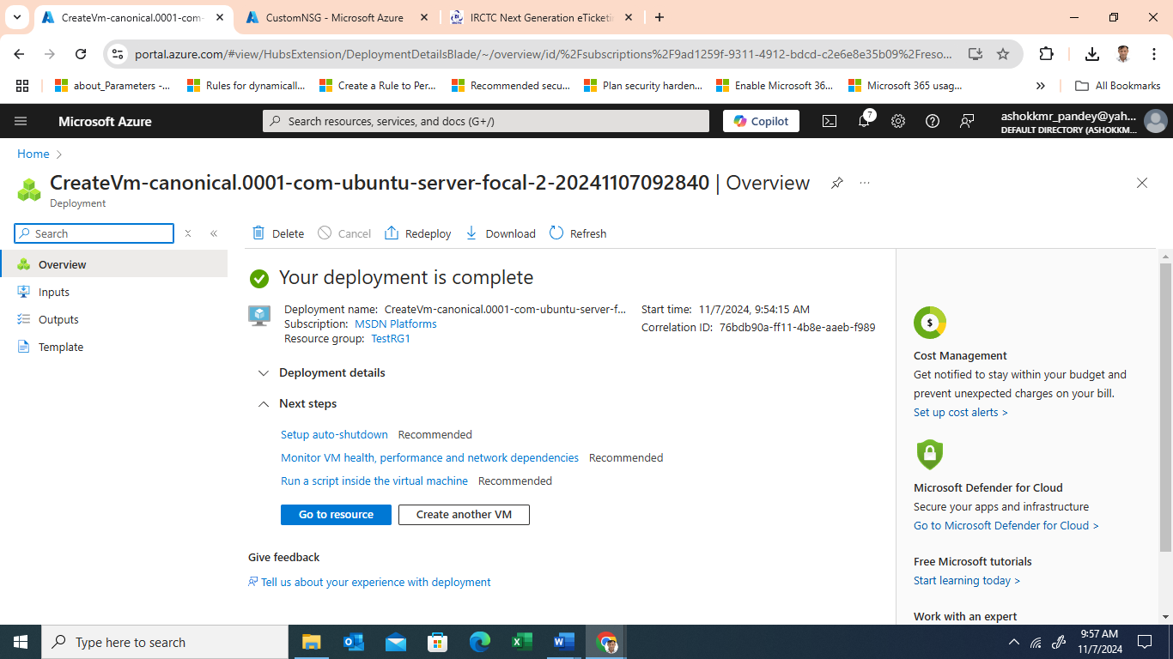

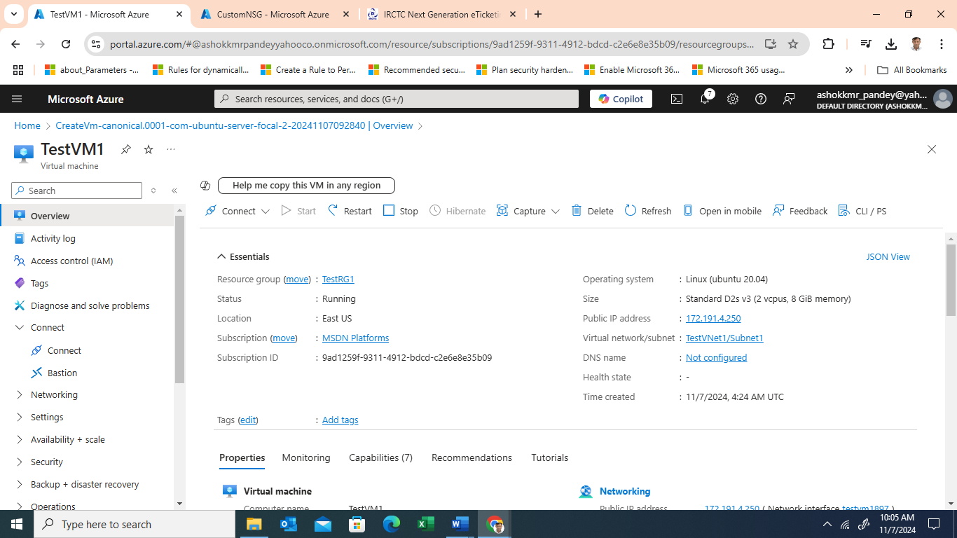

* + Select a VM size (e.g., Standard_B2s for testing purposes).
  + Associate the VM with the VNet and subnet created in Step 1 and apply the NSG created in Step 2.

1. **Configure Bastion for Secure SSH Access**

**Solution Architecture**

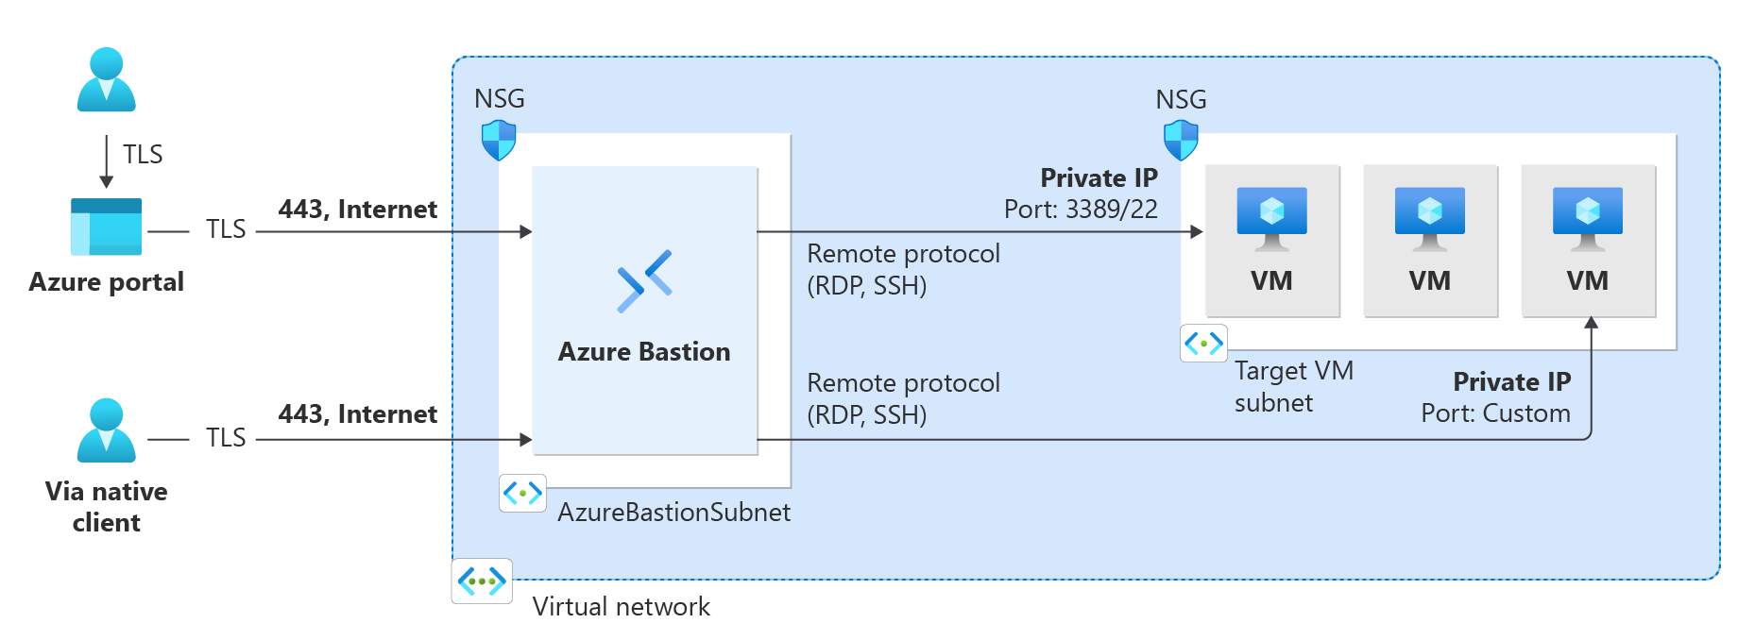

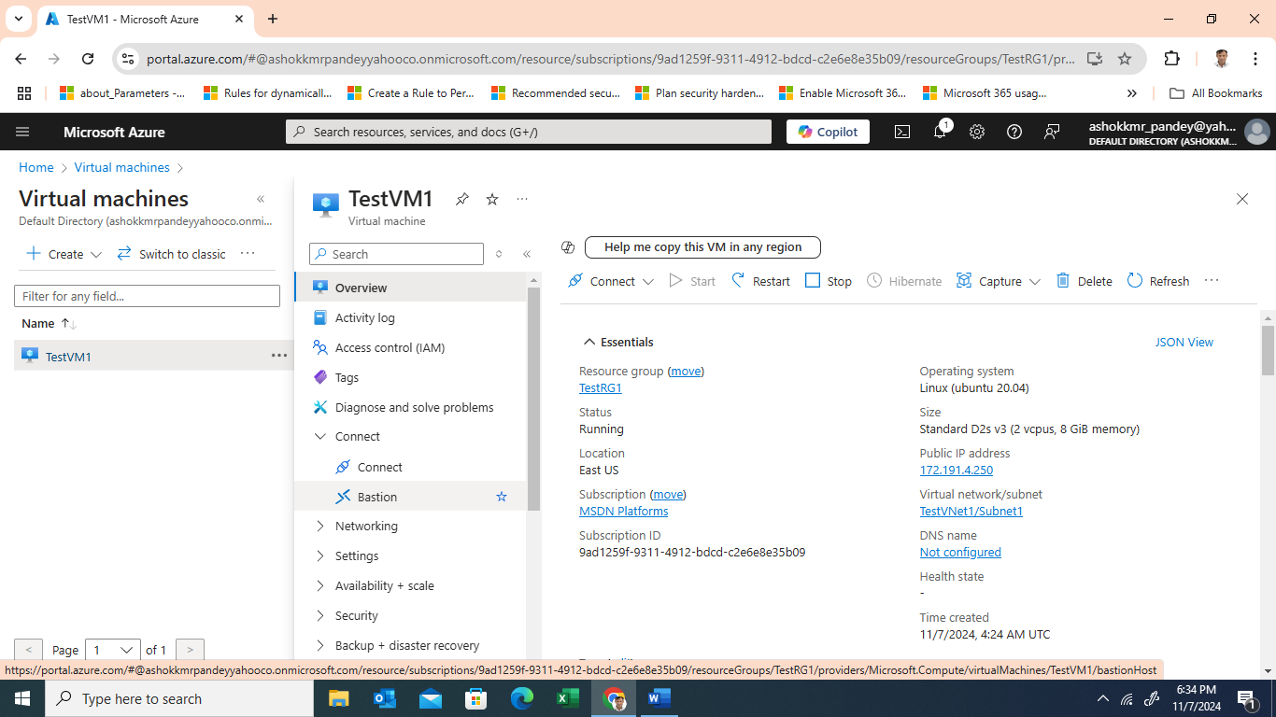

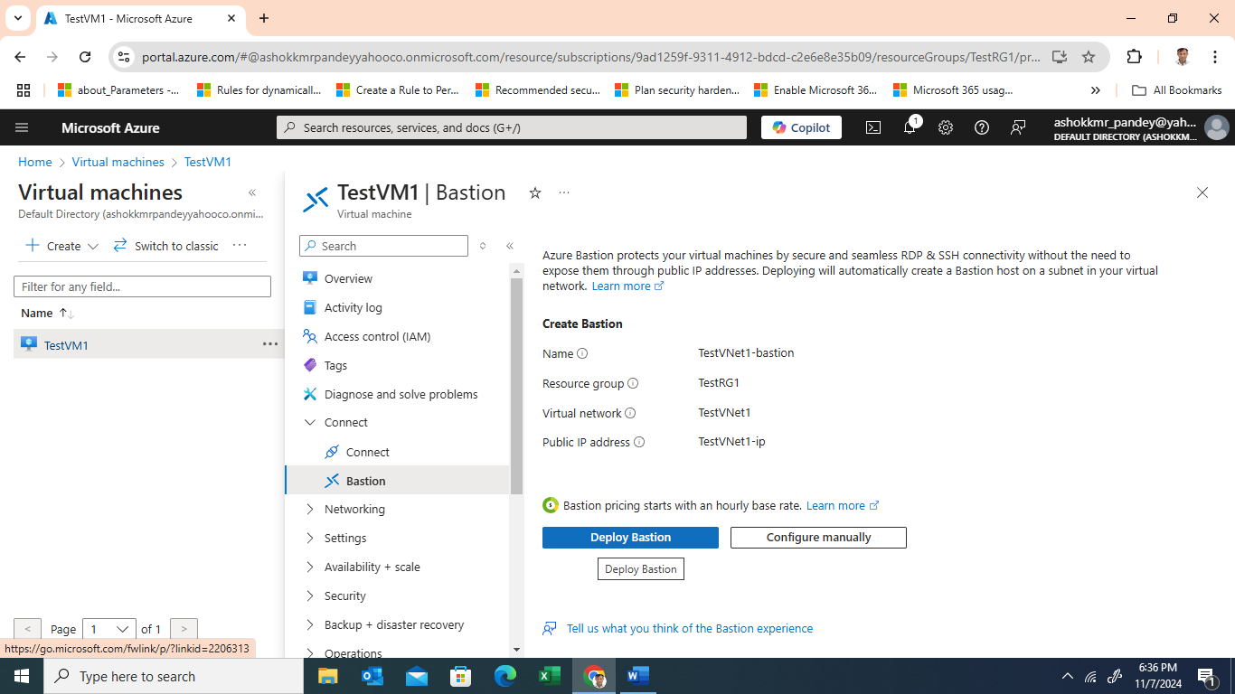

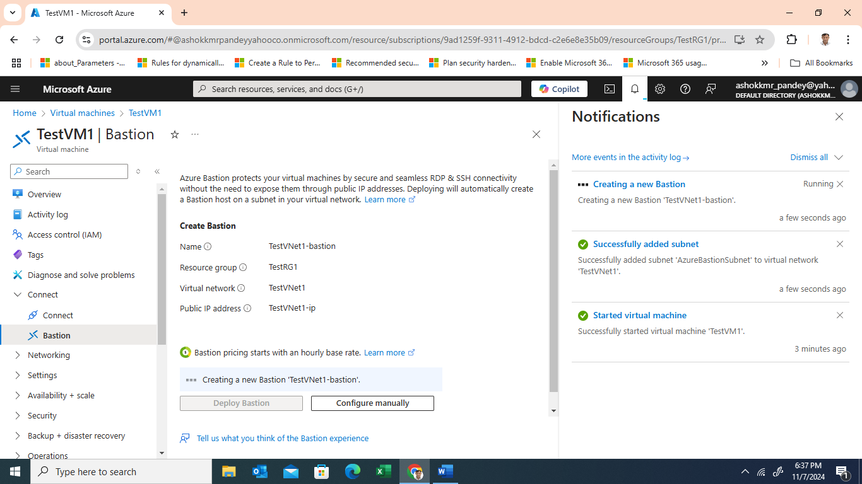

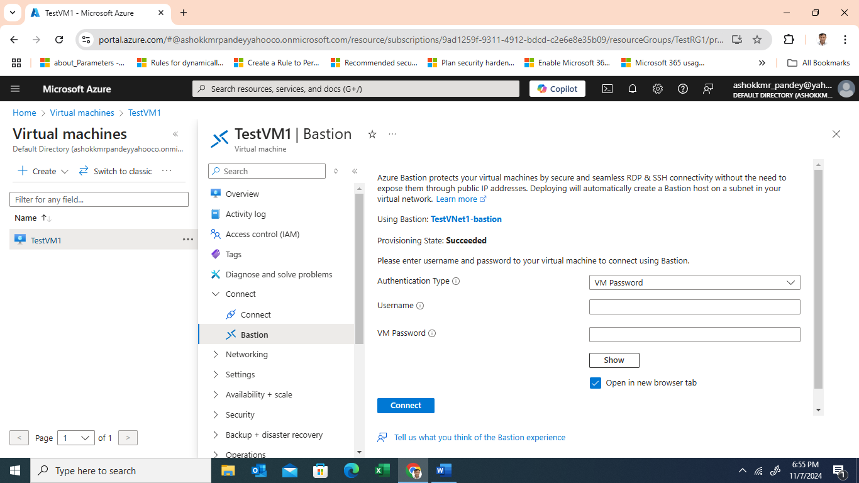

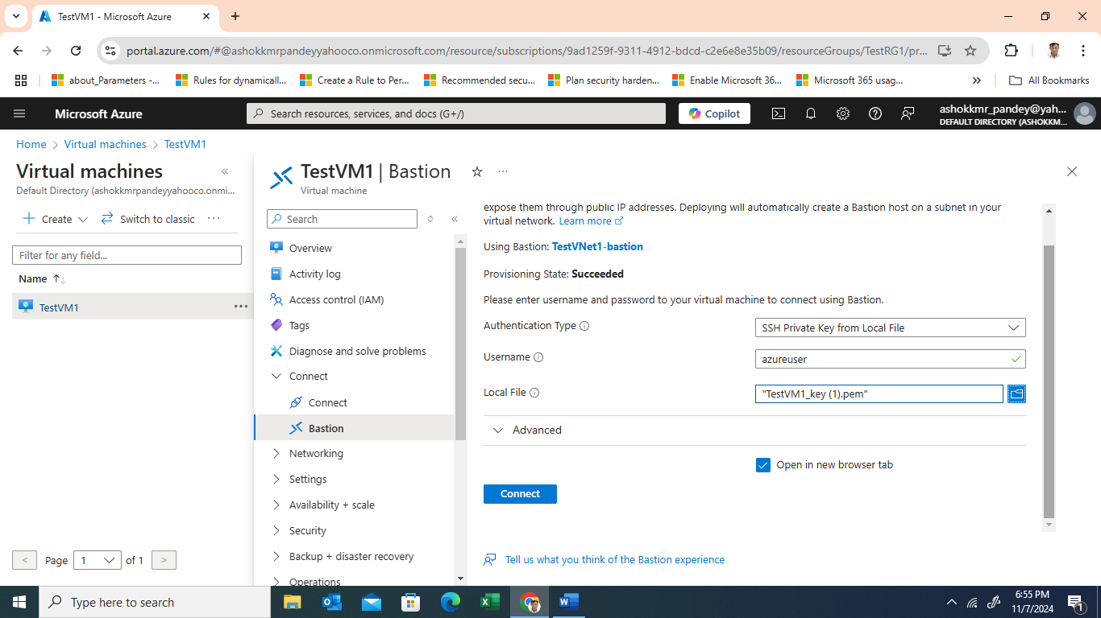

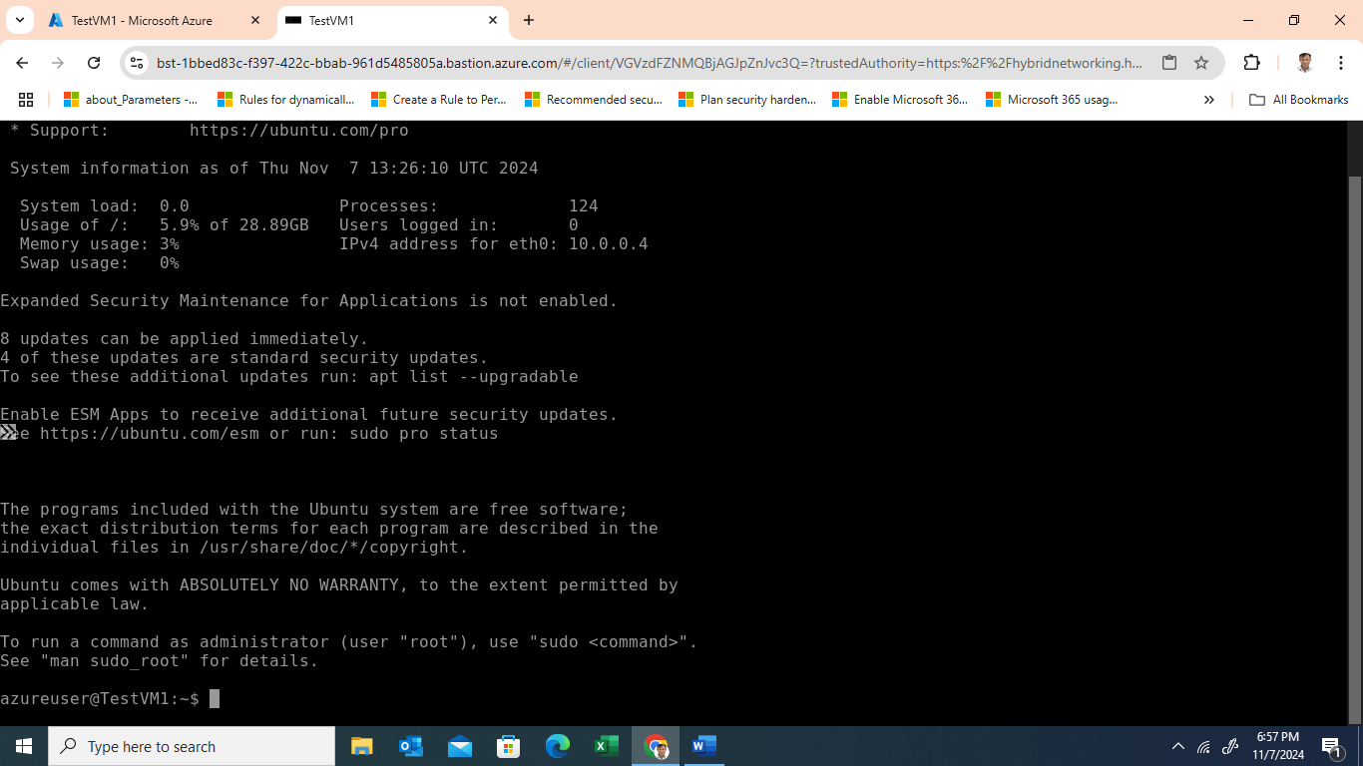

* + Navigate to the VM's settings and enable Azure Bastion, a secure SSH alternative that doesn't require open public ports.
  + Once deployed, connect to the VM via Bastion using SSH, ensuring external SSH access is unnecessary.

1. **Install the Nextcloud Server**
   * SSH into the VM using Azure Bastion.

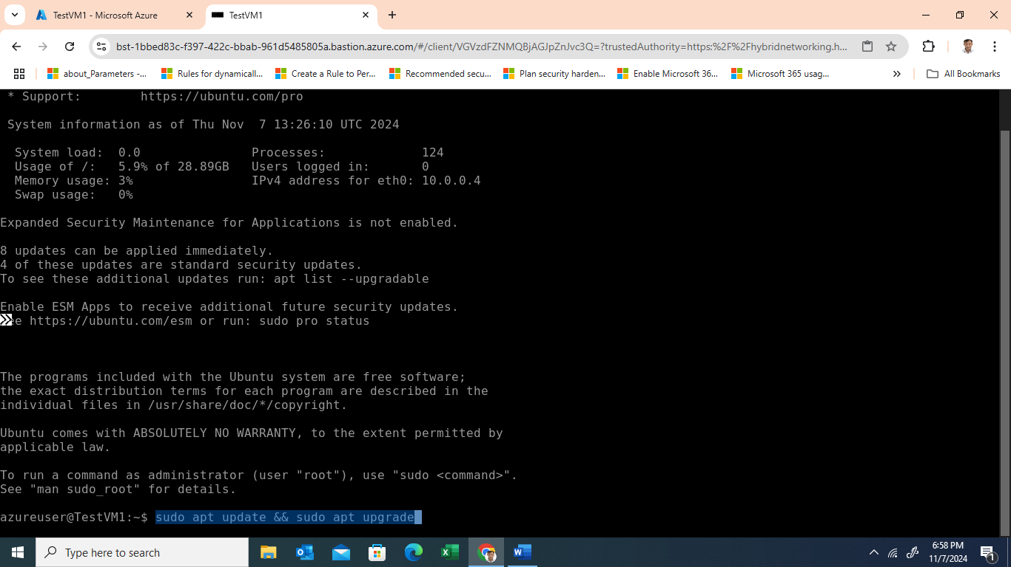

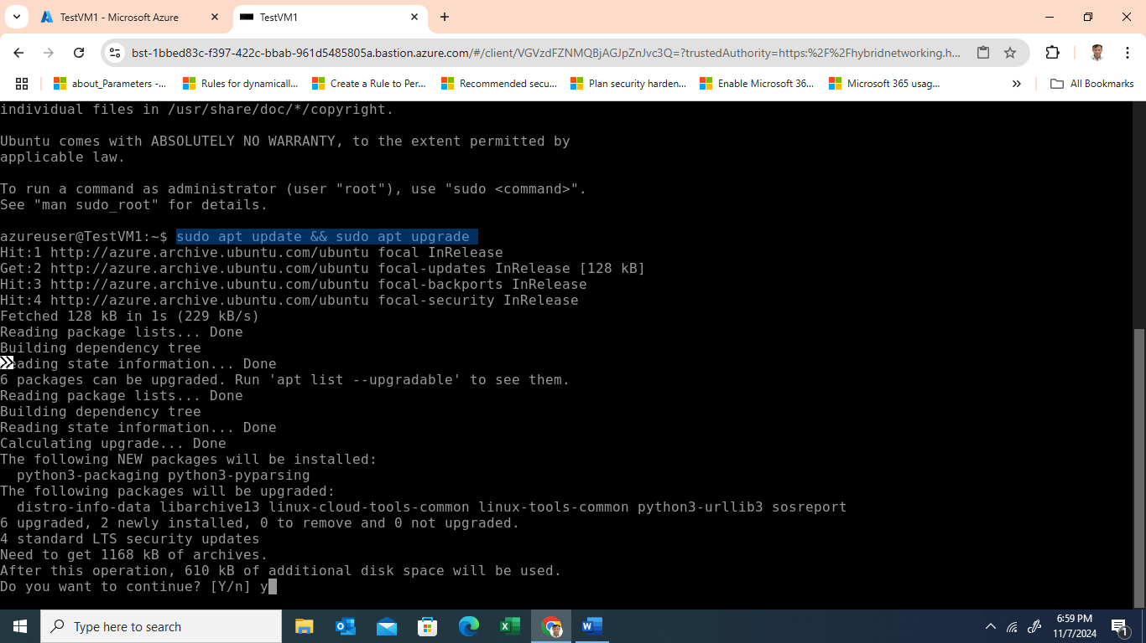

* + Update the VM: sudo apt update && sudo apt upgrade
  + Install the Apache web server, MySQL, PHP, and Nextcloud:

sudo apt install apache2 mysql-server php libapache2-mod-php

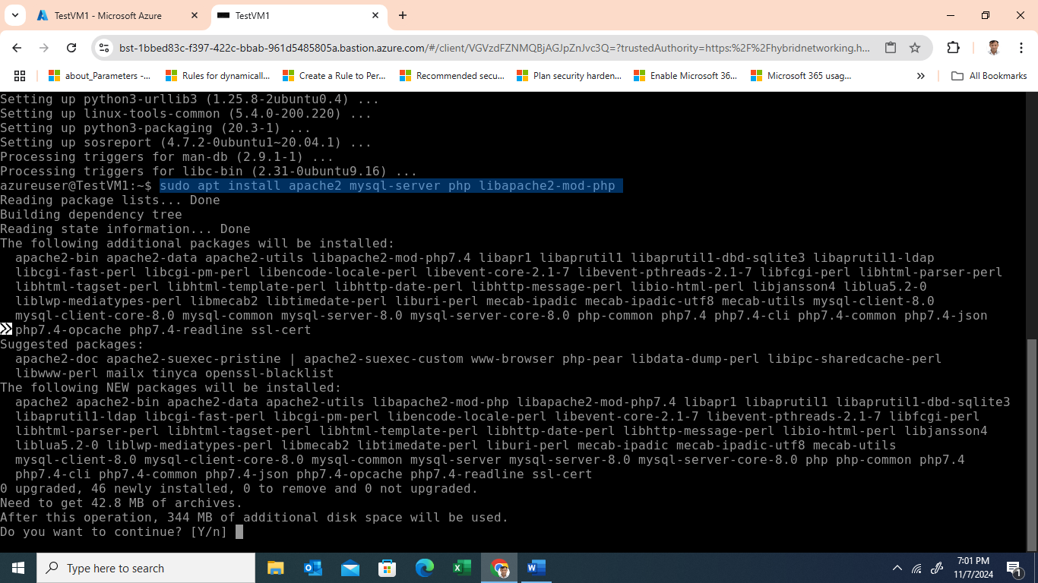

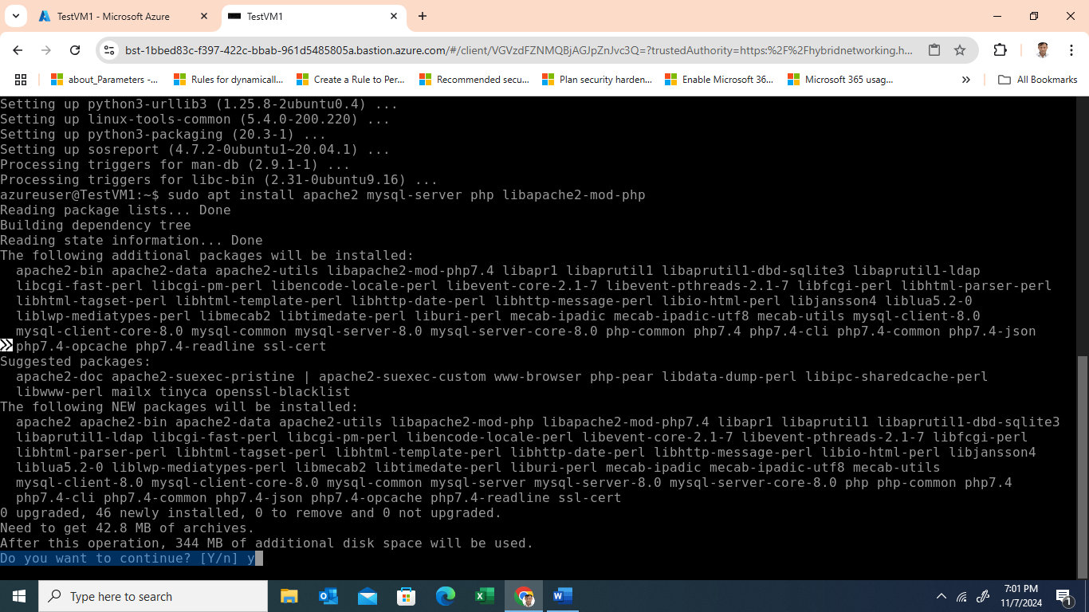

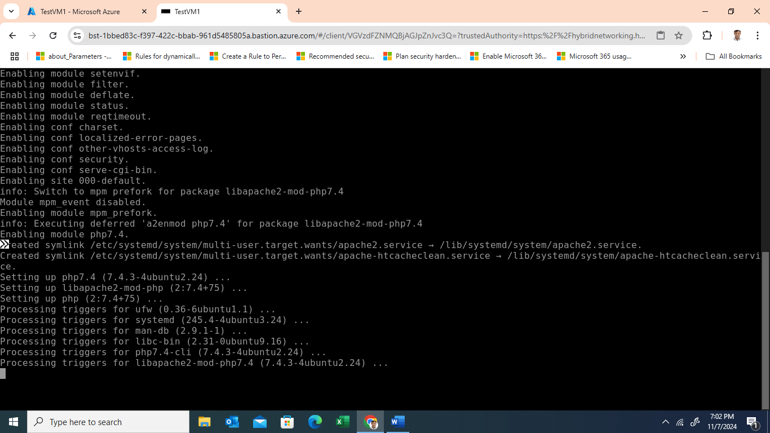

sudo apt install php-{cli,json,curl,gd,mbstring,intl,mysql,imagick,xml,zip}

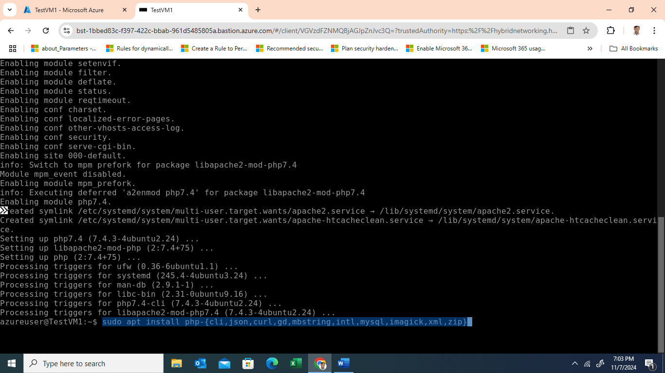

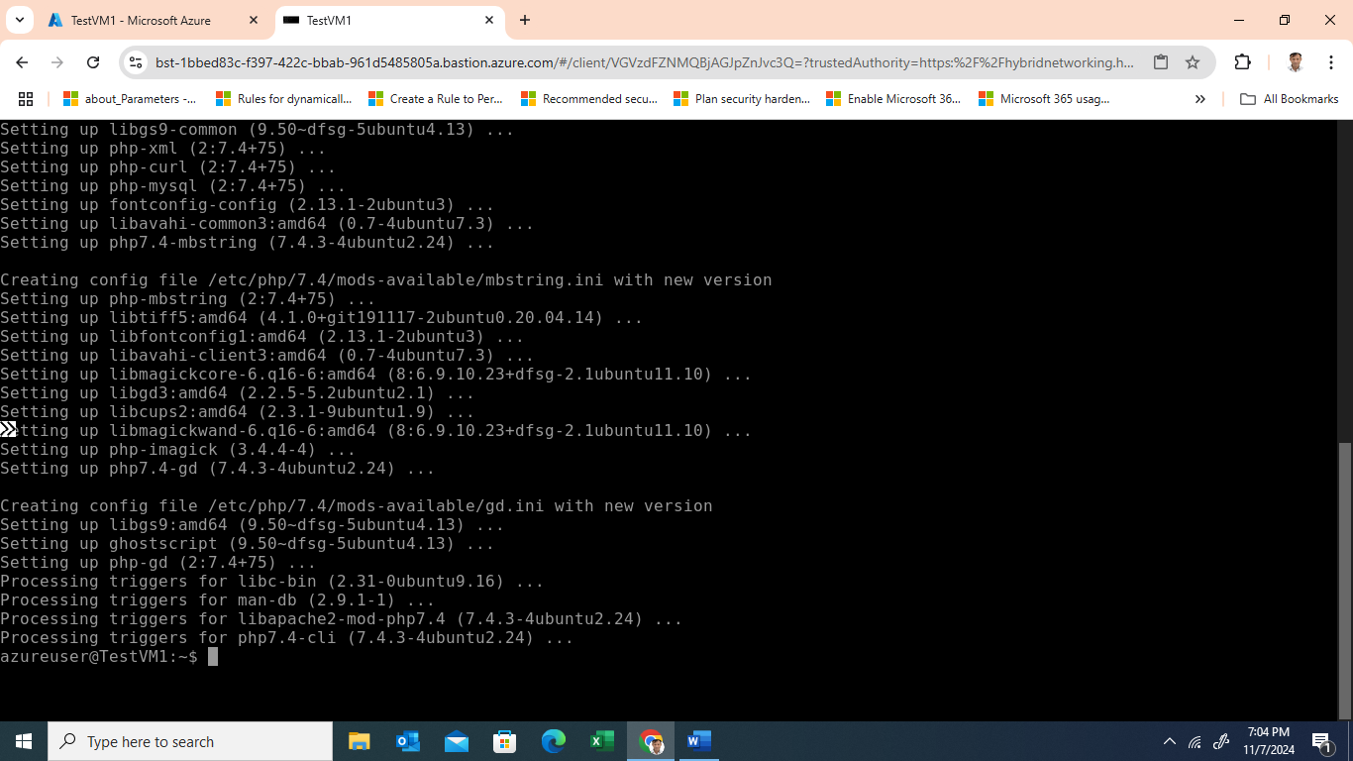

* + Download and configure Nextcloud:

cd /var/www/

sudo wget <https://download.nextcloud.com/server/releases/nextcloud-21.0.1.zip>

sudo apt install unzip -y

sudo unzip nextcloud-21.0.1.zip

sudo chown -R www-data:www-data nextcloud

sudo systemctl restart apache2

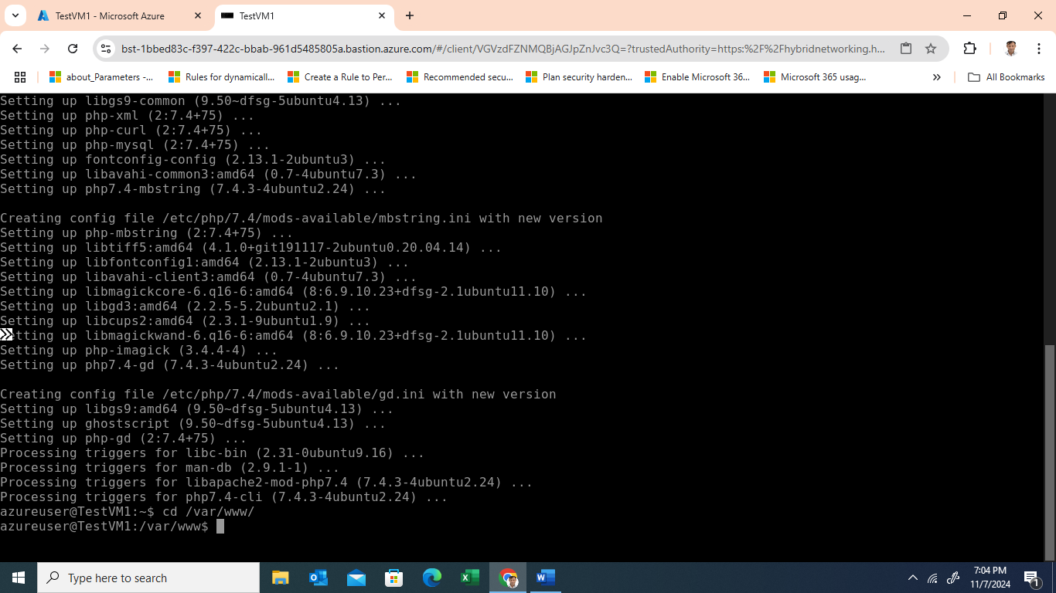

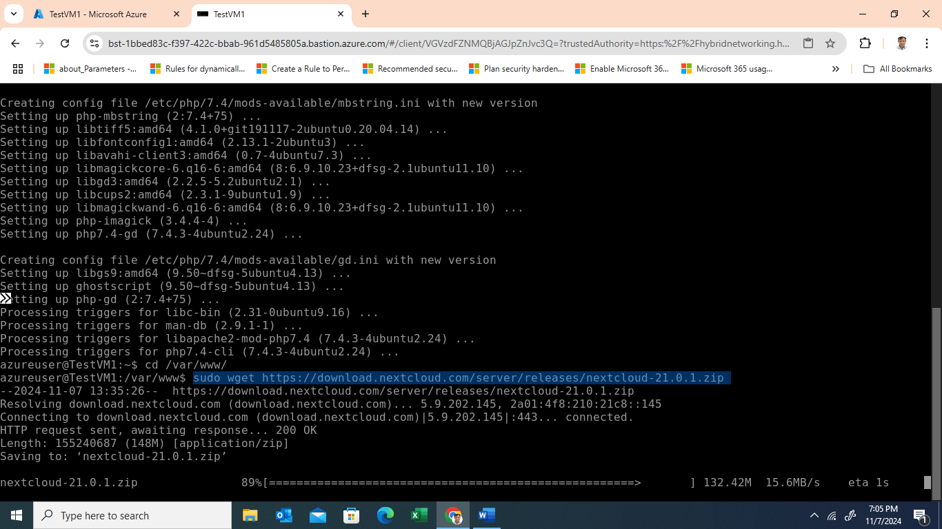

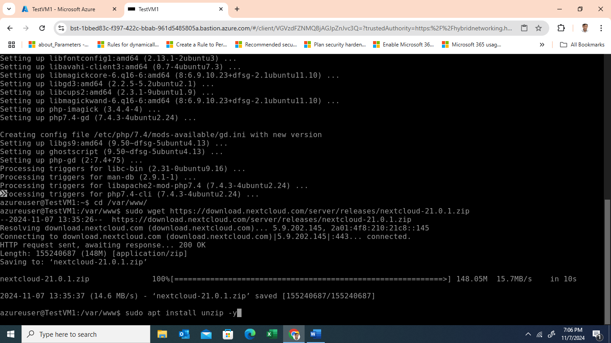

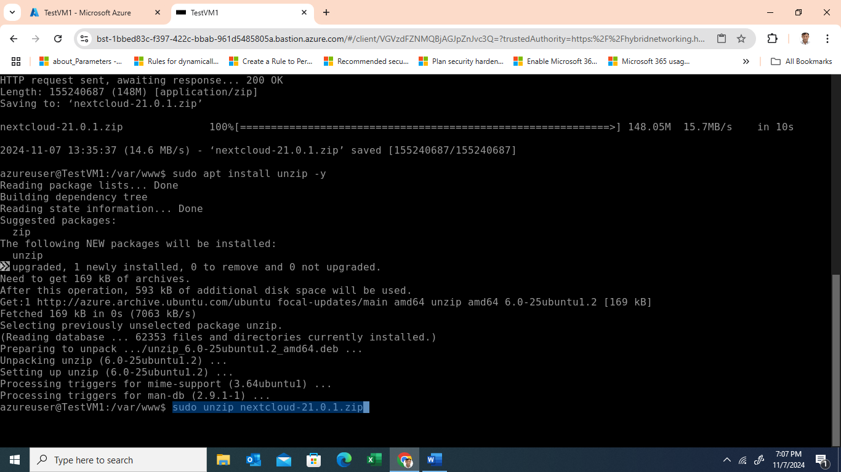

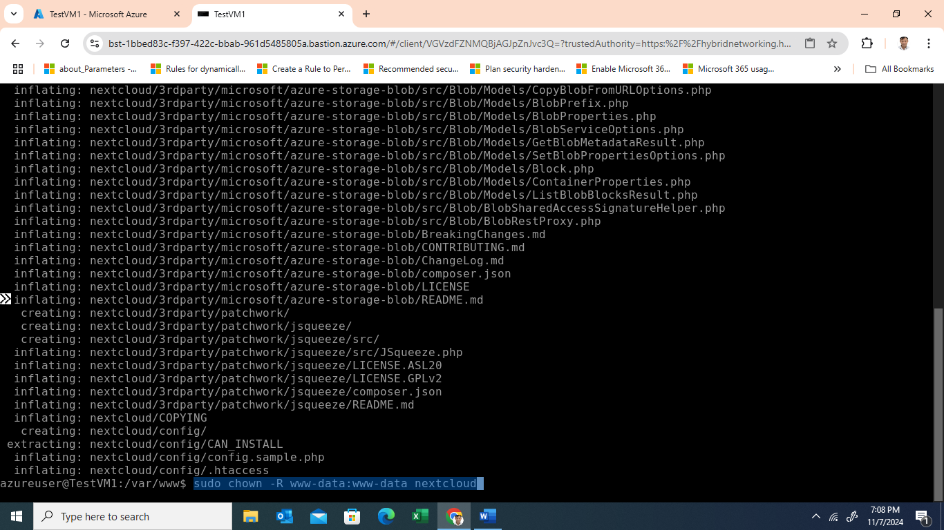

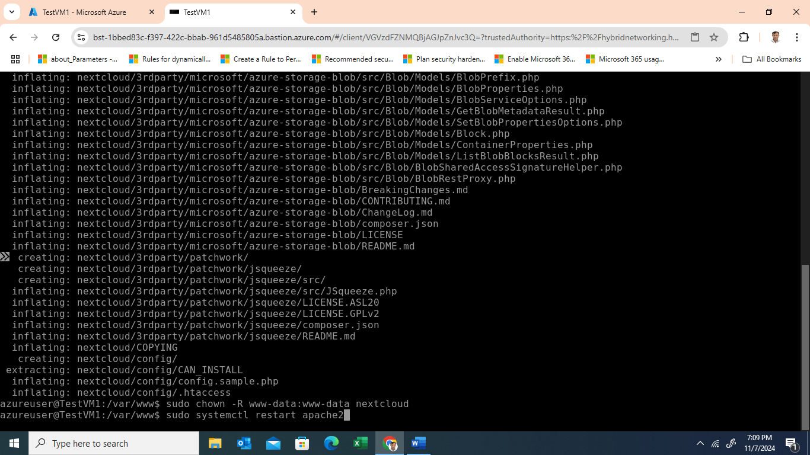

* + Access the server by navigating to http://<VM_public_IP>/nextcloud in your browser.

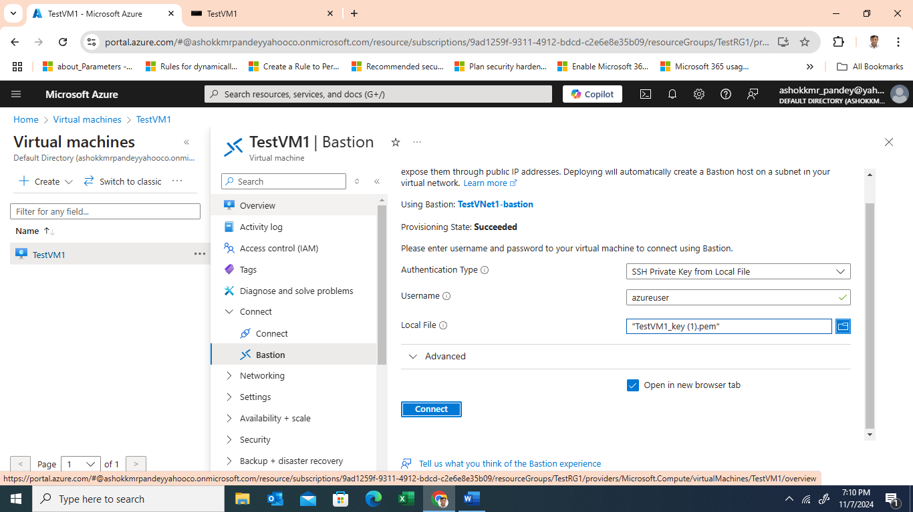

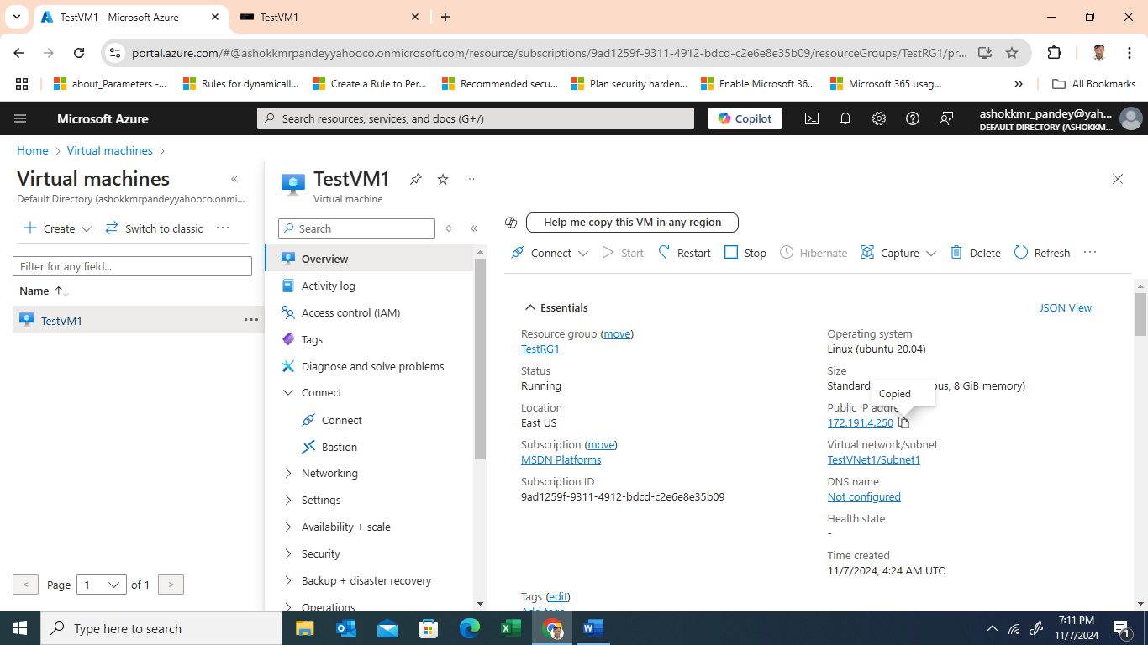



1. **Assign a Public IP and DNS Label**
   * In the VM's settings, assign a public IP and configure a DNS label for easier access (e.g., <your-vm-name>.centralus.cloudapp.azure.com).

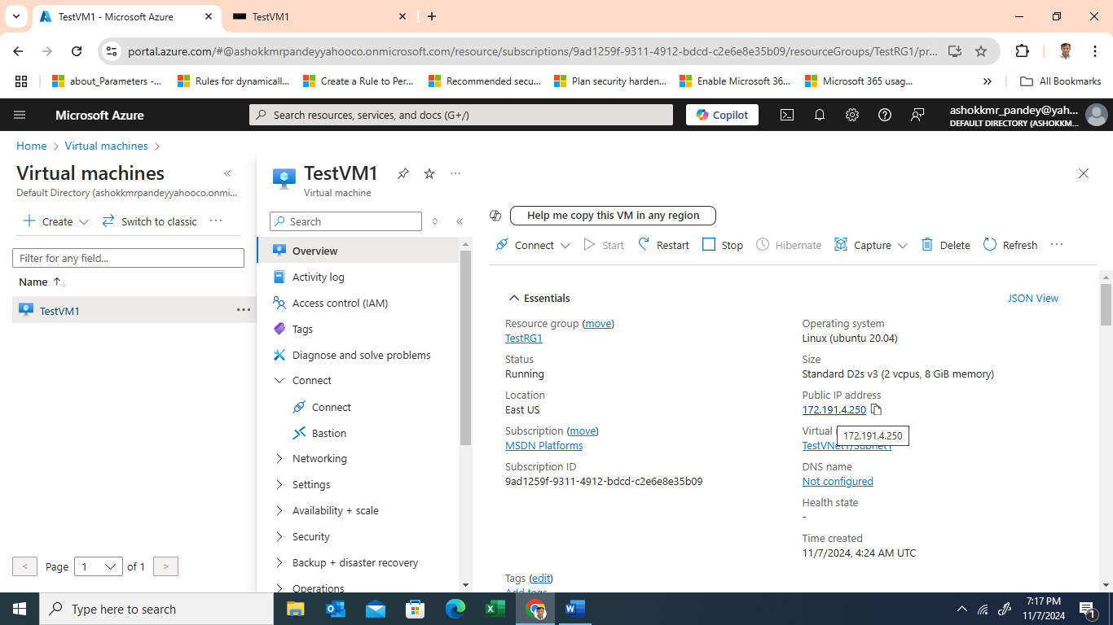

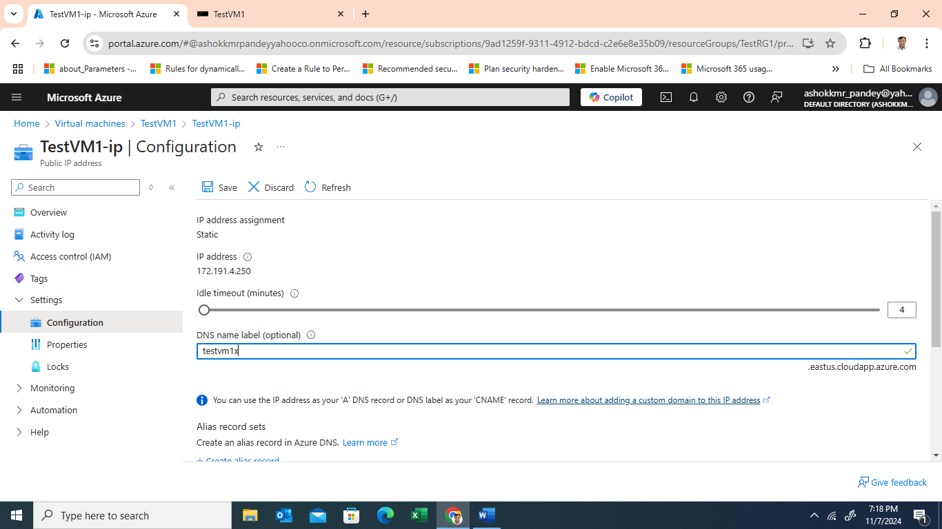

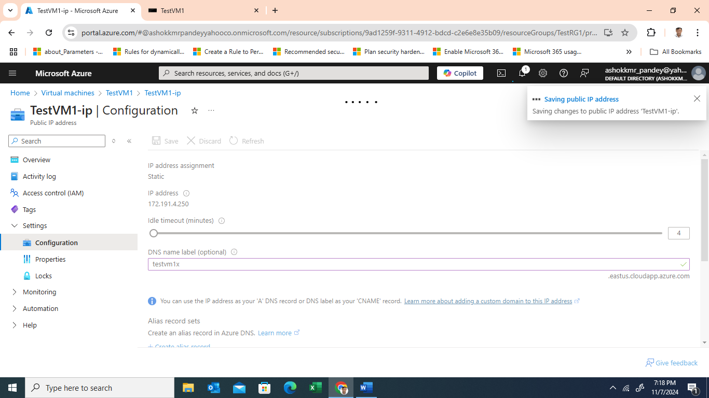



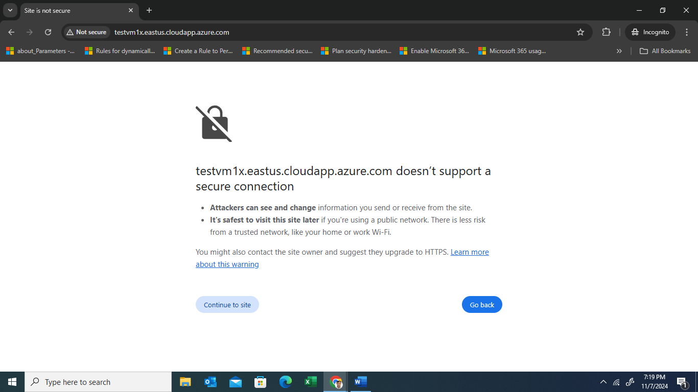

* + This allows you to access Nextcloud via a DNS name.

**Monitoring Features for Azure VM**

1. **Azure Monitor** 
   * **Create Alerts**: Configure alerts for CPU and memory thresholds (e.g., 80% usage) to notify you of potential performance bottlenecks.

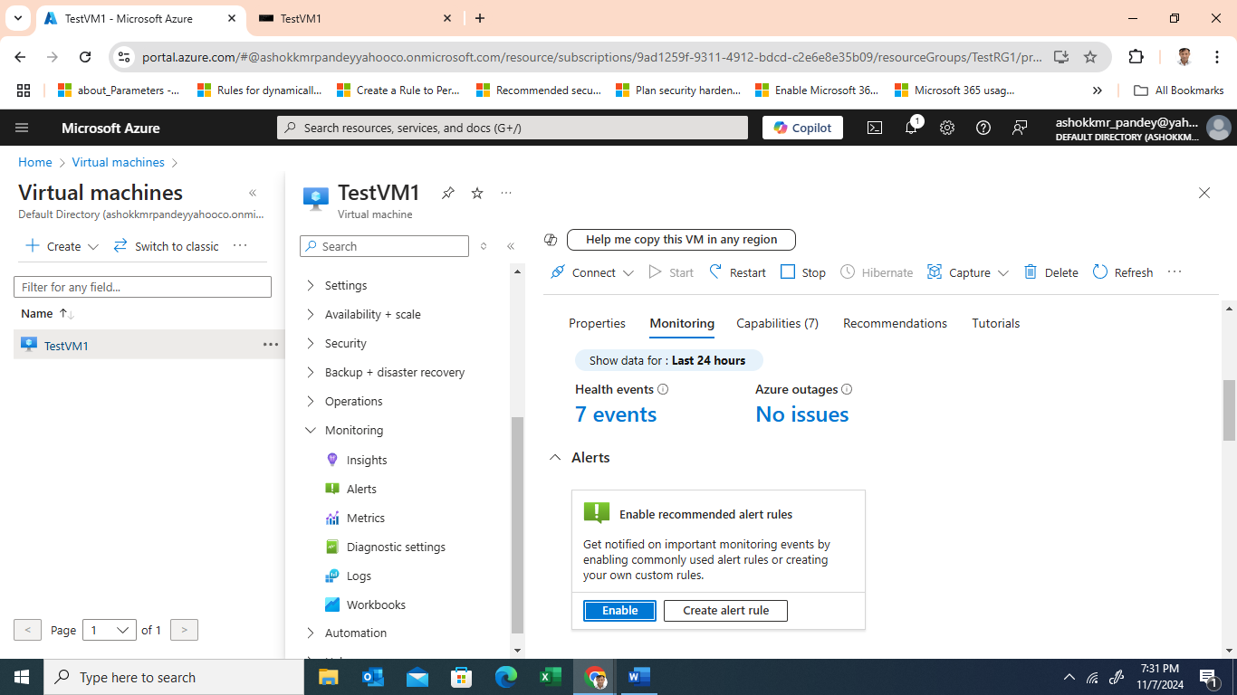

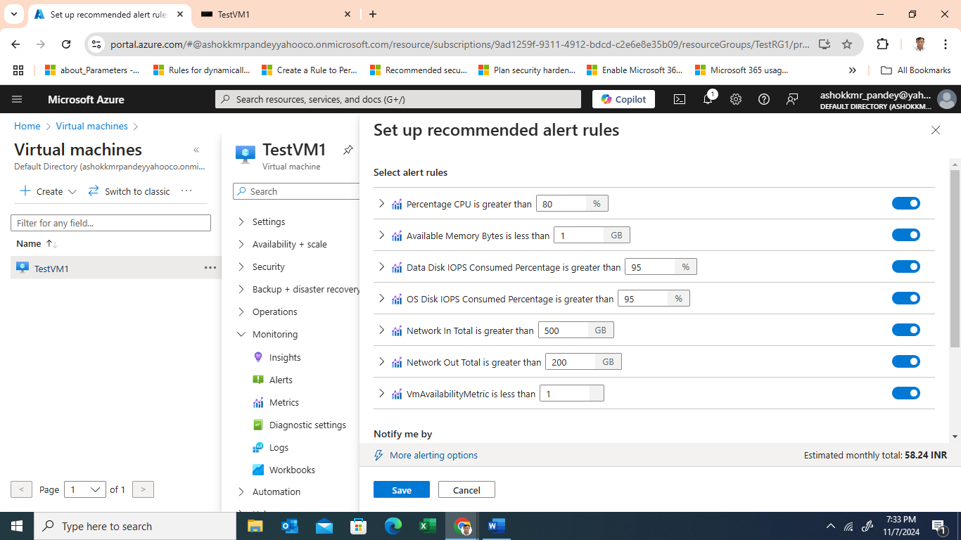

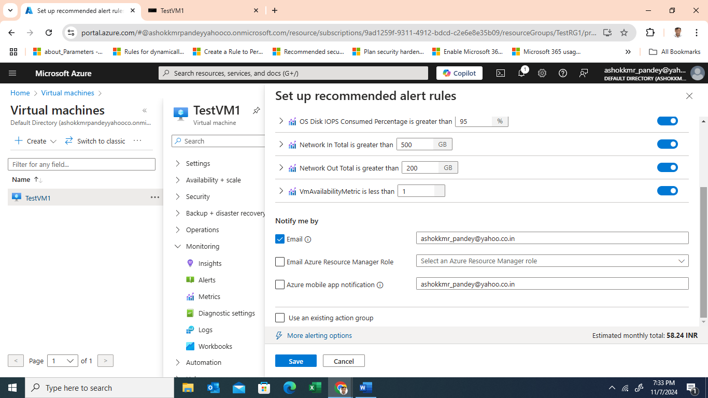

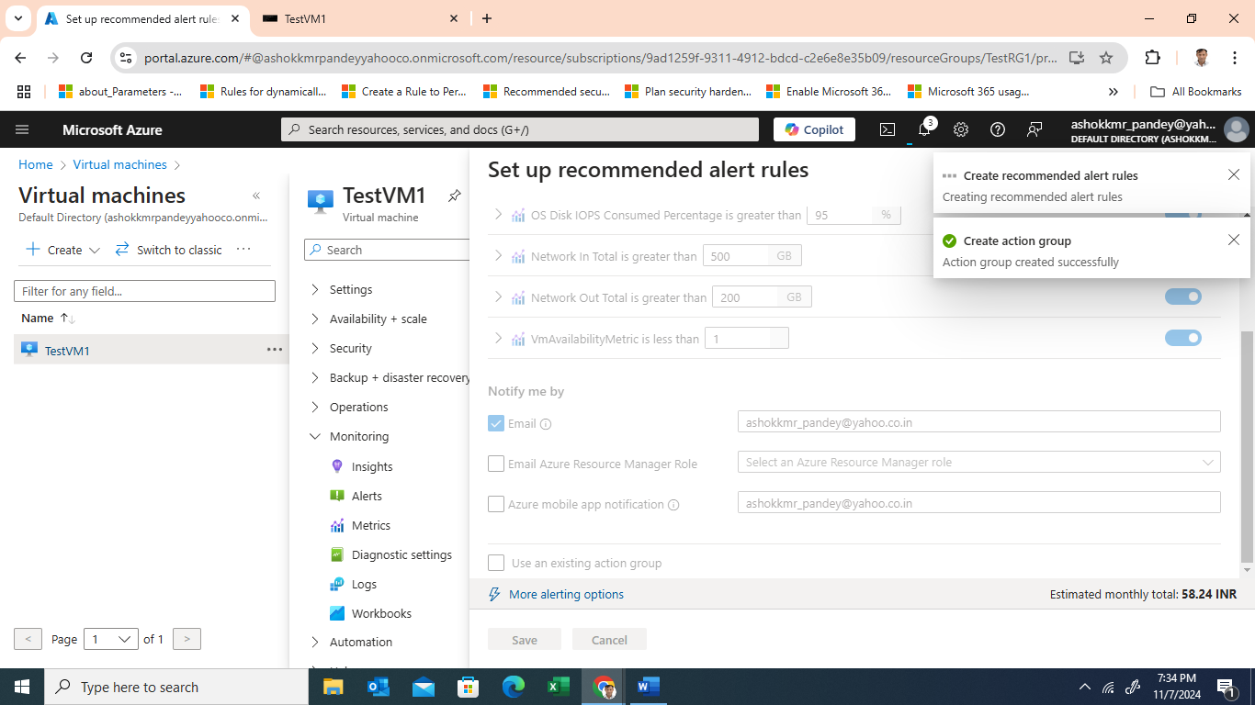

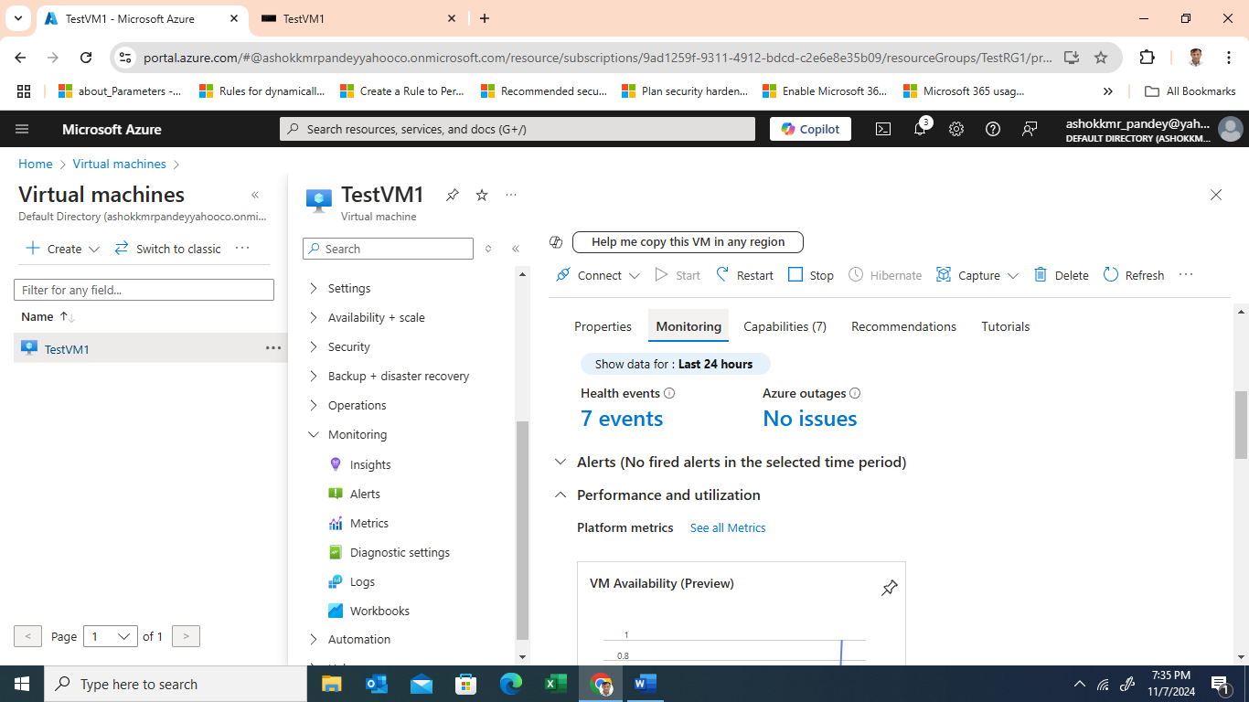

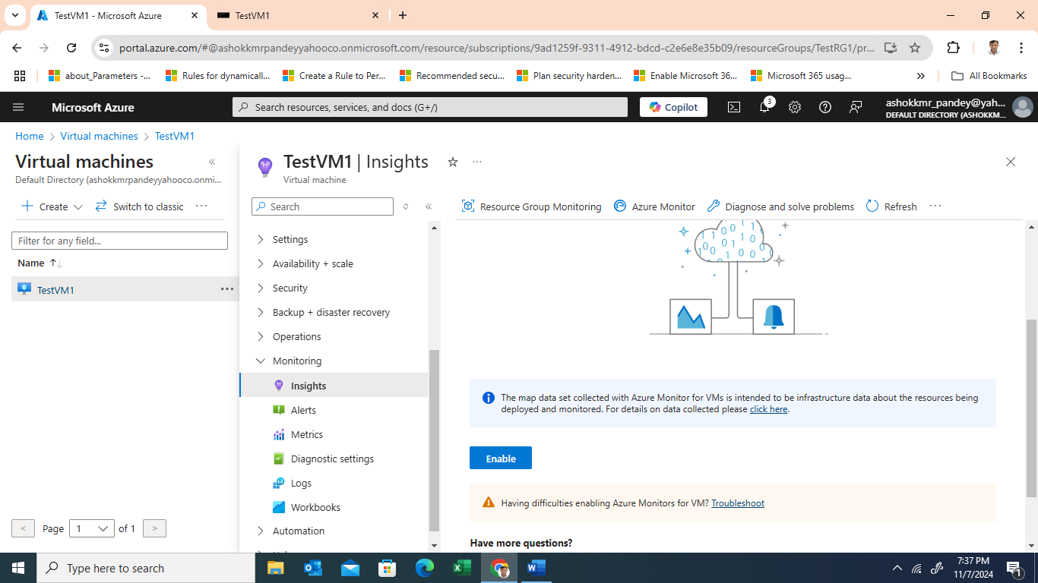

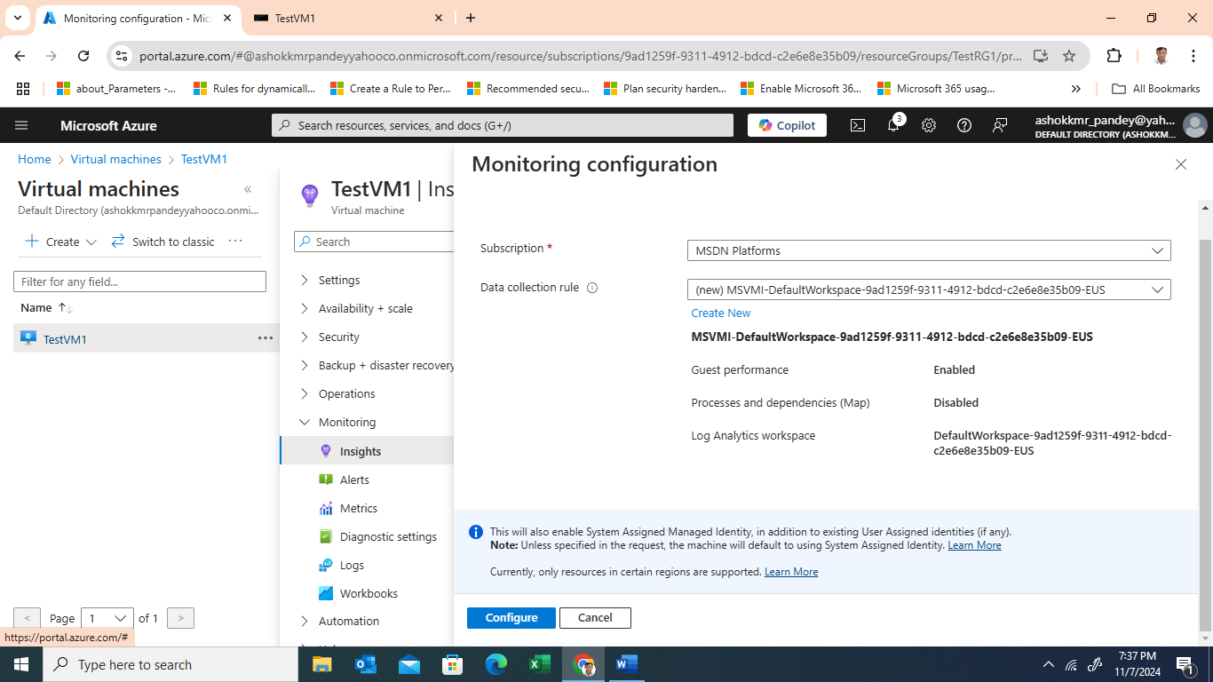

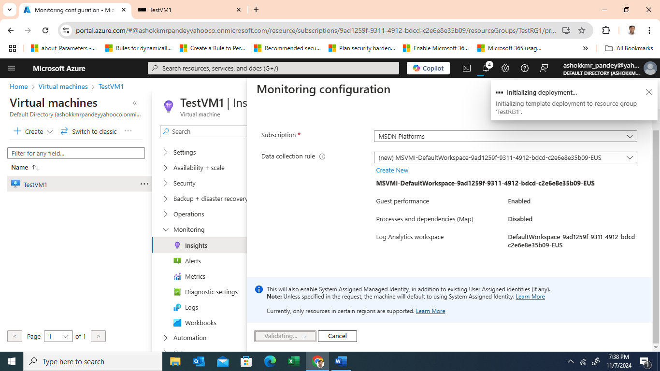

* + **Automated Analysis**: Utilize Azure's AI-driven insights to detect anomalies in resource utilization, helping you quickly identify performance issues.

1. **Log Analytics and Application Insights**
   * Use **Log Analytics** to gather detailed logs on server operations, error messages, and traffic to the Nextcloud application.
   * Enable **Application Insights** for end-to-end tracing, identifying high-latency requests, and monitoring response times, useful for troubleshooting traffic issues or slow page loads.
2. **Cost Management and Optimization**
   * Set up **cost alerts** and monitor cost-related metrics to reduce unnecessary compute, storage, or data transfer expenses.

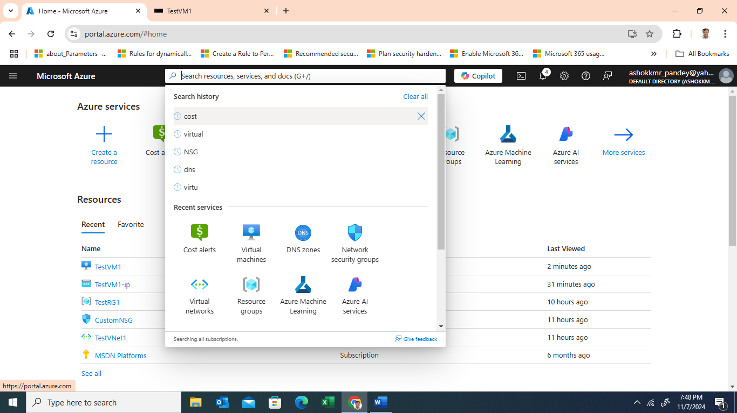

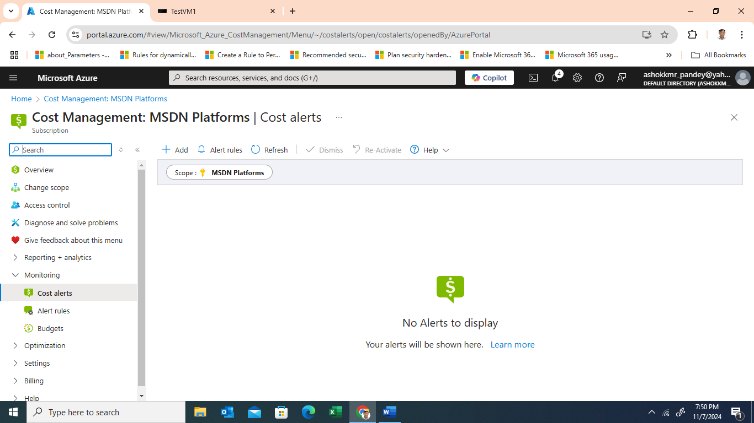

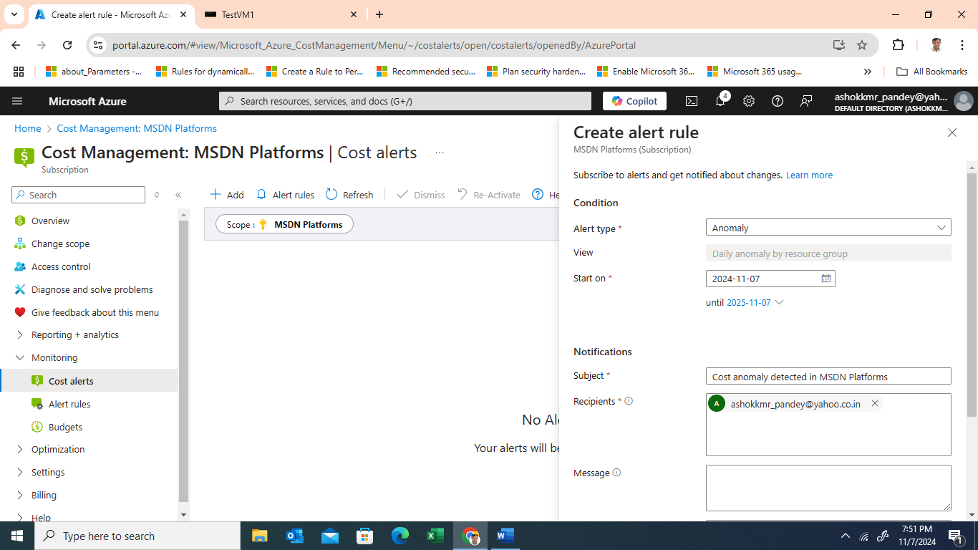

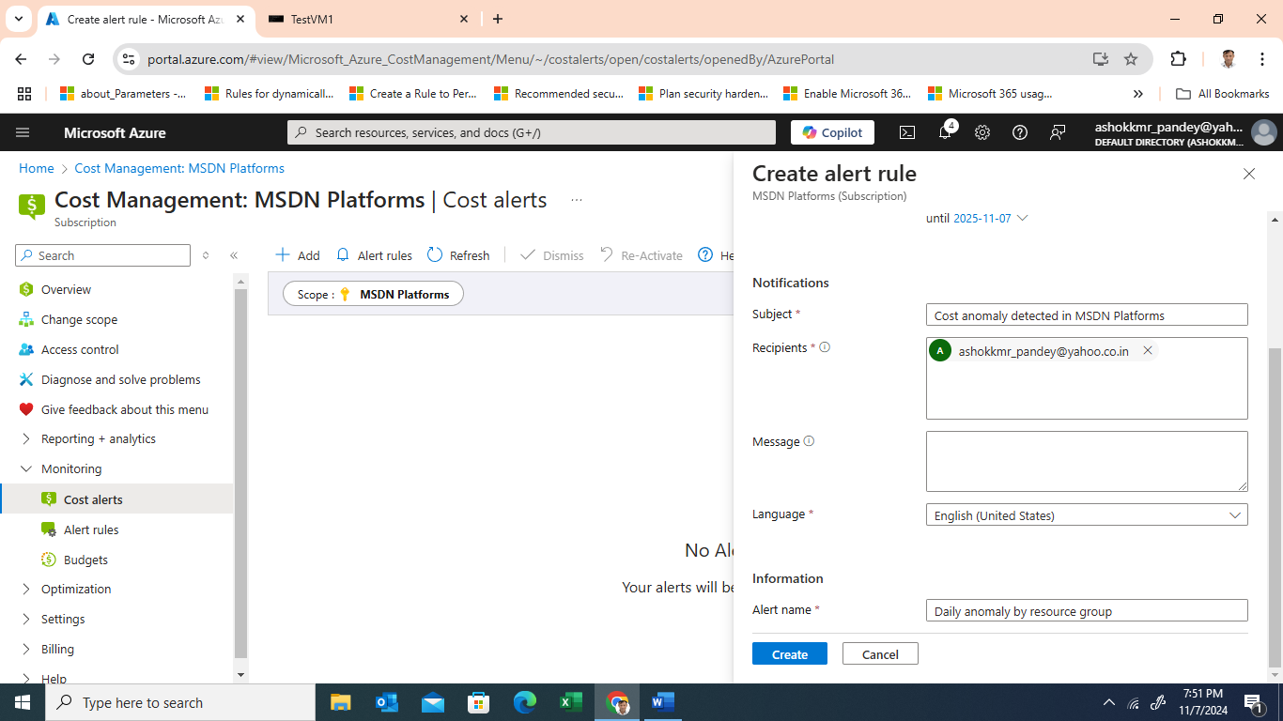

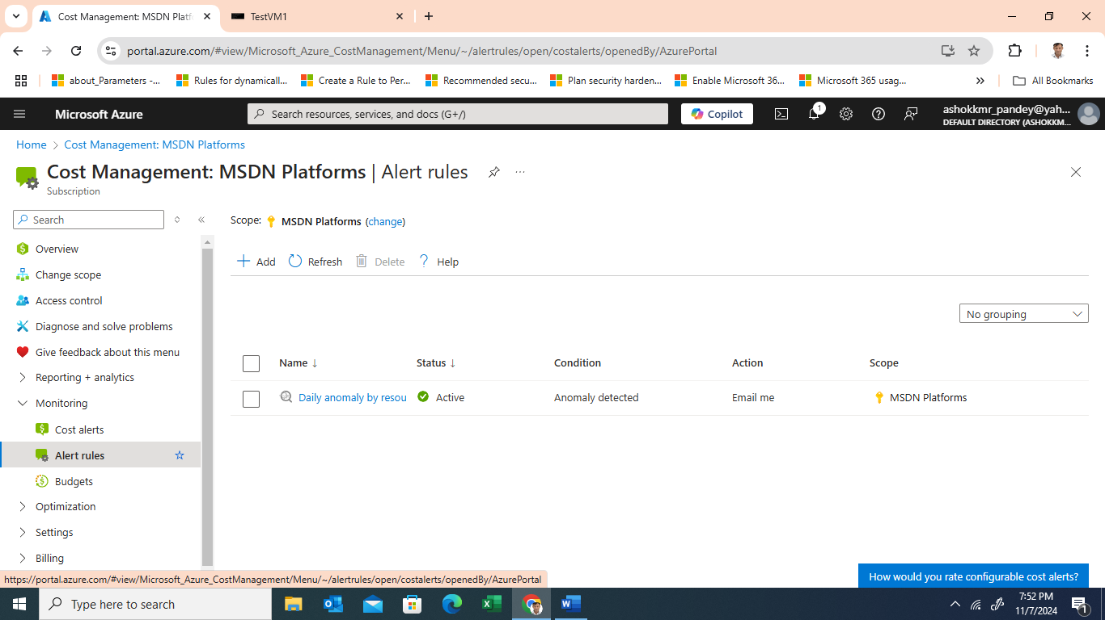

* + Review **resource utilization metrics** to ensure your VM is right-sized, optimizing CPU and memory to prevent over-provisioning.

**Risk Identification and Mitigation**

The Risk Identification and Migration section of the Solution Design Document details the process and company specific risks that need to be accounted for and mitigated in the solution design. The number of risks and effects of each risk typically increases as a company moves down the scale from their first few workloads in the cloud towards an all-in posture. It consists of four phases.

Step 1 – Identify Step

Enforce / Monitor • Cost analysis General purpose tier is available with: • 8 cores: $736.29/month • 16 cores: $1,472.58/month • 32 cores: $2,208.87/month A deployment comes with 32GiB of storage. Additional costs will include storage: Capacity: Each 32GiB block, up to 8TiB, will cost $0.0575/GB IOPS: Every 1 million requests will cost $0.10.